DATA CABLE
MEASUREMENT
SYSTEM

SOFTWARE
DOCUMENTATION

Rev 3.23.000

TABLE OF CONTENTS

1 INSTALLATION INSTRUCTIONS 6
1.1 Installing Cable Measurement Software 6
1.2 Add licensing file 6
1.3 Installing Instrument Drivers 6
1.4 Connecting Instruments 7
1.5 Configuring Software 8
1.6 Testing Setup 9
2 SOFTWARE OVERVIEW 10
2.1 Logon 10
2.2 Run Test 10
2.3 Calibrate 10
2.4 Test Setup Files 11
2.5 System Setup 12
2.6 Results 14
2.7 Help 15
3 SYSTEM PROPERTIES 16
3.1 System Properties Overview 16
3.2 Instruments Configuration 17
3.3 System Configuration 19
3.4 Logon Configuration 21
3.5 User Entry Configuration 21
3.6 Test Configuration 22
3.7 Results Configuration 23
3.8 Applications Configuration 24
4 EDIT USERS 26
4.1 Edit Users Overview 26
4.2 User Levels 28
5 INSTRUMENT SETUP FILE 29
5.1 Instrument Setup Overview 29
5.2 Instrument Setup Options 30
6 SPECIFICATION FILE 32
6.1 Specification File Overview 32
6.2 Simple View / Advanced View 33
6.3 Limit Entry 33
6.4 Math Facilities 33
6.5 Limit Checking Start & Stop 37
6.6 Advanced Math 37
6.7 Normalisation Length 39
6.8 Example Plot 39
6.9 Limit Checking 40
7 LIMIT MASK FILE 41
7.1 Limit Mask File Overview 41
7.2 Sub Equations 42
8 SEQUENCE FILE 43
8.1 Sequence File Overview 43
8.2 Sequence 45
8.3 Instrument Setup File 45
8.4 Specification File 46
8.5 Test Order 46
8.6 Description 46
8.7 Prompt Files 46
9 PRODUCT FILE 49
9.1 Product File Overview 49
9.2 Product Code 50
9.3 Product Description 50
9.4 Pairs 50
9.5 Length (m) 50
9.6 Sequence File 50
9.7 Min User 50
9.8 Pair Colours 51
10 User Defined Tests 52
10.1 Test Name 52
10.2 Source Path 53
10.3 Measure Path 53
10.4 Measurement 53
10.5 Formatting 53
10.6 Length Compensation 53
10.7 Temperature Correction 53
10.8 Other Math 53
10.9 Upper Limit 54
10.10 Lower Limit 54
10.11 Limit Mask File 54
10.12 Limit Link to Spec file 54
11 RESULTS 57
11.1 Results Overview 57
11.2 Results Format 58
12 SYSTEM OPERATION 61
12.1 Measurement Procedure 61
12.2 Test Configuration Summary 71
13 RF CALIBRATION 73
13.1 RF Calibration Overview 73
13.2 Balun Calibration 74
13.3 Balunless Calibration 75
13.4 Thru Calibration 78
13.5 Open Calibration 80
13.6 Short Calibration 80
13.7 Load Calibration 80
13.8 Calibration Frequency 80
13.9 Previous Calibration 81
13.10 Viewing Calibration Data 81
14 LF CALIBRATION 84
14.1 LF Calibration Overview 84
14.2 Open (Capacitance) 84
14.3 Thru (DC Resistance) 85
15 MEASUREMENT DEFINITIONS 87
15.1 Impedance 87
15.2 Fitted Impedance 88
15.3 Return Loss 89
15.4 Structural Return Loss 90
15.5 Insertion Loss 90
15.6 NEXT 93
15.7 FEXT 95
15.8 ACR 96
15.9 ELFEXT 97
15.10 Group Delay 97
15.11 Velocity of Propagation 98
15.12 Delay 99
15.13 Skew 100
15.14 LCL 100
15.15 TCL 100
15.16 LCTL 101
15.17 TCTL 101
15.18 ELLCTL 101
15.19 ELTCTL 101
15.20 Attenuation Deviation 101
15.21 Surface Transfer Impedance 102
15.22 DC Resistance 102
15.23 DC Resistance Unbalanced 102
15.24 DC Resistance Unbalanced (Pair-Pair) 103
15.25 Capacitance Unbalance (Pair-Ground) 104
15.26 Capacitance Unbalance (Pair-Pair) 104
15.27 Mutual Capacitance 105
15.28 DC Resistance Unbalance Pair to Pair 105
15.29 Mutual Conductance 105
16 Manual Switch Configuration 107
16.1 RF Switching 107
16.2 LF Switching 108
16.3 Instrument Setup 109
16.4 GPIB Test 110
16.5 Math 110
17 DIAGNOSTICS 112
17.1 Diagnostics Overview 112
17.2 Instrument Self-Test 112
17.3 Bad Switch List 112
17.4 Instrument Driver Setup 113
17.5 Run I/O Config 114
17.6 Trouble Shooting 115
18 CUSTOM REPORTS 124
18.1 Report Overview 124
18.2 System Property Reporting Options 124
18.3 Running Reports 125
18.4 Configuring Reports 126
18.5 Profiles 127
18.6 Results File 128
18.7 Creating Bespoke Reports 129
18.8 Report Definition File 130
18.9 [GENERAL] Section 130
18.10 [HEADER] Section 133
18.11 [REPORT] Section 135
18.12 [GRAPH] Section 136
18.13 [TABLE] Section 140
18.14 Example Report Definition File 143
19 DATABASING 147
19.1 Configuring System Properties 147
19.2 Database Operation 148
19.3 Configuring Database 149
19.4 [GENERAL] Section 152
19.5 [KEY] Section 153
19.6 [TABLE] Section 153
19.7 [FIELD] Section 153
20 SYSTEM SUPPORT 157
20.1 Agilent Instrumentation Support 157
20.2 Software Support 158
20.3 Fixture Support 158

INSTALLATION INSTRUCTIONS

To install the test software, complete the following steps:

(Please note, this procedure is only suitable for Windows 7 and above. If you are running an older version of Windows, please contact CSS for installation details)

Installing Cable Measurement Software

Download, and unpack the following zip file:

http://allpack.notlong.com

Then run the Setup.exe program, and follow the default prompts to install.

Once installation is complete, ensure you are running the latest software, by downloading the following files:

http://creativesoftware.org/download/Cabtest.exe

http://creativesoftware.org/download/reports.exe

Copy Cabtest.exe to C:\CableTest\

Copy reports.exe to C:\CableTest\Reports\

Add licensing file

You will need a license file Cabtest.lic in order to run the software.

Please copy this file to C:\CableTest\

If you do not have this file, please contact Support@CreativeSoftware.org to obtain one.

Installing Instrument Drivers

From the CSS download page (https://www.creativesoftware.org/), download and install the Keysight IO Libraries, using all the default settings.

If you are using a USB switch unit (like one used with the Balunless system), you should also download and un-zip the USB Fixture Driver from the same download page.

Connecting Instruments

Now connect and power on all the instruments.

If you have a USB fixture, when Windows prompts for the driver, point it to the files downloaded in the last section.

We now need to get the SICL addresses for each instrument. To do this, double-click the IO icon located in the Windows System tray. This will load the IO Libraries.

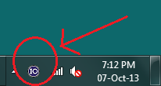

From the main IO Libraries screen, click on each instrument name in turn and record the SICL address for each one (you may want to Cut & Paste these and store them in Notepad temporarily).

For example, the GPIB card in this system has a SICL address of gpib0. Please note, this address is case sensitive.

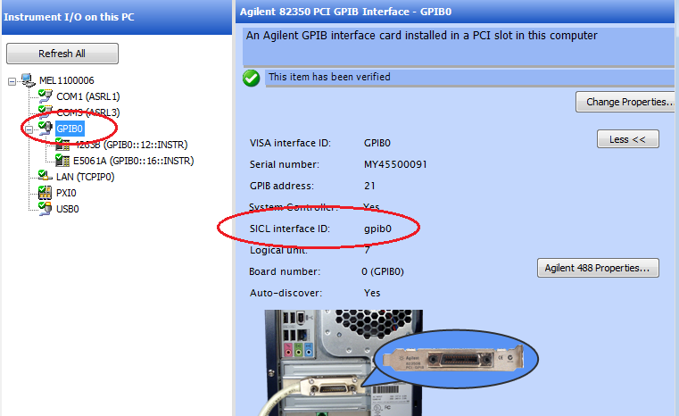

If your fixture is using a USB or RS232 connection, you will also need the SICL address for this. In this example the RS232 SICL address is COM1.

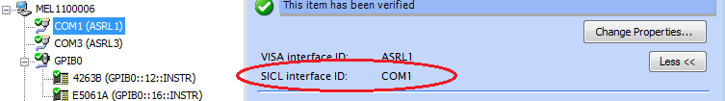

Some newer instruments may have very long SICL names, particularly if you are connecting to them over USB, as shown in the following example:

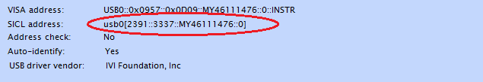

With such a long SICL name, it is advisable to Cut & Paste the name in this instance.

Once you have recorded all the SICL names, move on to the next step.

Configuring Software

The Cable Measurement software should now be located at C:\CableTest\CabTest.exe

Double-click the Cabtest.exe icon to run the software.
From the main menu, select System Setup, System Properties, and click the Instrument tab.

From this screen, select the Analyzer model, and enter the SICL addresses for all the instruments that you recorded in Step 4 (as shown in the picture below)

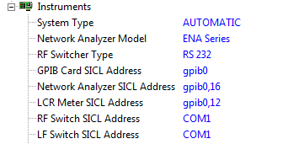

Testing Setup

In order to check that everything is operating correctly, once all the SICL addresses have been entered, from the main menu, select:

System Setup, Diagnostic, Fault Finding, Instrument Self Test

If everything is operating correctly, you should see a screen like the once below, with all PASSES. If any of the entries FAIL, these should be investigated further. It will most likely be caused by the wrong SICL address being entered, or the instrument not being connected.

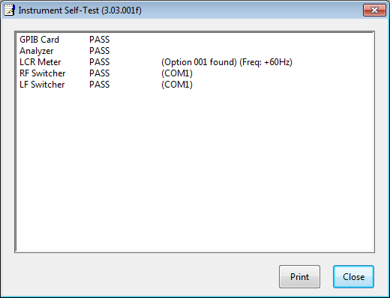

SOFTWARE OVERVIEW

The facilities offered to the user from the main menu (see screen shot below) are described in the sections below.

Main Menu drop down menus.

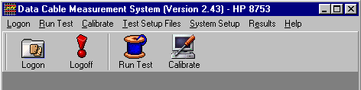

Logon

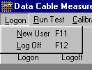

New User
Allows a user name and password to be entered. This sets the user level, and determines which of the main menu options are made available.

Log Off
Logs the current user off the system.

Run Test

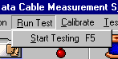

Start Testing
Allows a product to be selected, and automatically tested.

Calibrate

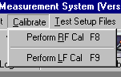

Perform RF Cal
Allows an instrument setup to be selected, and performs the High Frequency calibration for it.

Perform LF Cal
Calibrates the system for Low Frequency tests.

Test Setup Files

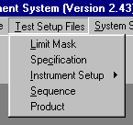

Limit Mask
The limits mask file is referred to in the specification file. This is used where a limit line is made up of several different of step lines, for example the return loss limit

Specification
The specification file contains all the references to the specification being tested for each test. For example, each variant of the EIA/TIA specifications would have its own file (ie: Cat 5, Cat 5 Patch, Cat 5e etc.)

Instrument Setup
The instrument setup file allows the configuration for the analyzer to be set. Features such as the IF Bandwidth, start and stop frequencies and the number of points can be set. A separate menu item is available for each different model of network analyzer.

Sequence
The sequence file allows the type of tests, and the order in which they are run to be configured.

Product
The product file includes details of the different types of cable being tested including a description and the number of pairs. Each file will typically be set-up as a different type of cable, for example all of the Category 5 Cable products may be grouped together.

System Setup

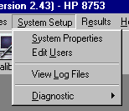

System Properties
All the various settings of the system are configured here, to do with the operation and configuration of the testing.

Edit Users
Allows the user names and passwords to be setup.

View Log Files
Every action performed on the system is stored to a log file. This option displays the directory of the log files, selecting a log file loads it into a text viewer.

Diagnostic
These options are for diagnostic purposes when there is a problem with the system, or for routine maintenance by engineers.

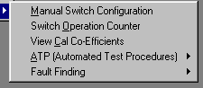

Manual Switch Configuration
Allows switch positions to be manually configured by clicking on a graphical view of the fixture.

Switch Operation Counter
Counts the number of switch operations performed on each individual switch to allow the life and operation of the switch banks to be tracked.

View Cal Co-Efficients
Allows the calibration co-efficients to be viewed for a selected calibration file. The values are displayed in a text box, and can be exported into another package such as Excel if required.

ATP (Automated Test Procedures)
Contains a number of automated procedures for checking and reporting on the operation of the test system. These procedures will normally be run by the manufacturers prior to delivery of the system.

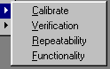

Calibrate
Calibrates the system for the ATP. This is an extra slow calibration to allow the system noise floor to be as low as possible.

Verification
Performs a verification check on the system. This consists of a check on the transmission, by running an Attenuation measurement on the Thru cable, a check of reflection by running an Impedance Termination test on each balun with 100Ohm load on, and a check on the noise floor of the system,

Repeatability
This option performs a repeatability test on the system, by running some tests on a cable, then prompting the user to swap the ends of the cable over, then re-running the same tests. The results are then correlated for repeatability. The effects of the cable should follow the pair positions, and not remain with the baluns.

Functionality
This performs a basic functionality test, by running all the measurements that the system is capable of.

Fault Finding

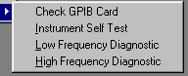

Check GPIB Card
Performs a basic test to check communication between the PC and the GPIB card.

Instrument Self Test
Performs a high-level basic self-test of each instrument connected to the system to ensure that, firstly they are connected properly and secondly that no major faults can be detected.

Low Frequency Diagnostic
When run, this option will lead the engineer through a series of basic tests for verifying that the low frequency fixture is correctly wired and there are no cabling faults.

High Frequency Diagnostic
When run, this option will lead the engineer through a series of basic tests for verifying that the high frequency fixture is correctly wired and there are no cabling faults. Please note, this is not a check of RF performance, just a high level check for major faults.

Results

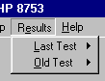

Last Test

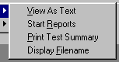

View As Text
Loads the textual results of the last test into Word Pad for viewing.

Start Reports
Loads the results of the last test into the report software.

Print Test Summary
Prints the test summary (exactly the same as shown at the end of a test) for the last test.

Old Test

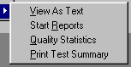

View As Text
Displays the results directory, and allows a set of old test results to be selected, and loaded into Word Pad for viewing.

Start Reports
Displays the results directory, and allows a set of old test results to be selected, and loaded into the result software.

Quality Statistics
Loads the quality statistics software package. This allows post processing on old test results.

Print Test Summary
Prints the test summary (exactly the same as shown at the end of a test), for an old test as selected from the results directory.

Help

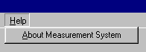

About Measurement System
Displays the standard Windows About screen, which contains Program version information and details about available Windows resources.

SYSTEM PROPERTIES

System Properties Overview

The system properties are selected by clicking on the System Setup, System Properties menu items.

Selecting System Properties

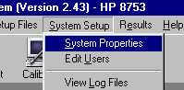

The system properties screen defines all aspects of the operation of the test system. Each category can be selected by clicking the + symbol.

System Properties Screen

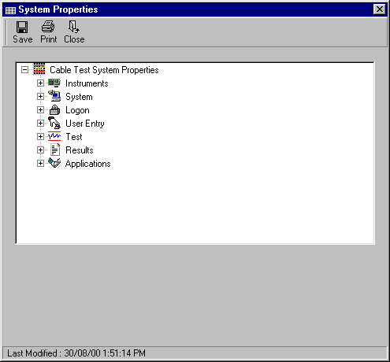

From the Category display, you can edit each option by clicking on it. The options are displayed in a box at the bottom of the screen, along with a full description.

Editing an option

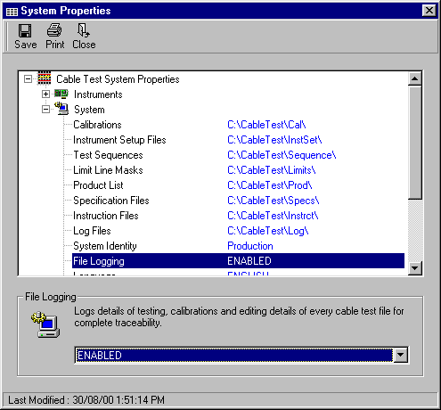

The following sections describe all the options that can be configured from the properties screen.

Instruments Configuration

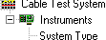

The following options can be configured from the Instruments section:

System Type
Automatic mode uses the full 4 pair fixture, Semi-Automatic mode forces the system to use a manual fixture or the >4 pair connection method.

Network Analyzer
The Network Analyzer model currently connected to the system. Supported analyzers are: 8753, 8752, 8751 and 8712 (also works for 8714).

RF Switcher Type
The RF Switcher Type used to connect the cable to the Analyzer. The currently shipped standard is the RS232. Previous switcher types are included for backward compatibility with older systems.

GPIB Card Select Code
The GPIB card select code. Setting this to 0 allows the system to run in a demonstration mode without any instruments attached. 7 is the default value for all standard installations, the only time you would want to change this, is if you were running more than one GPIB card from the same PC. You can also specify the full SICL name, eg: ‘gpib0’ would be a valid entry, which is the default used in the IO Libraries for an Agilent GPIB card.

Network Analyzer Address
The GPIB address for the Network Analyzer. 16 is the default value. It is worth noting when setting the GPIB addresses, that most network analyzers use two addresses (e.g. 16 & 17) so it is important not to set any other instruments to the address immediately after the analyzer address. Alternatively, the full analyzer SICL address can be entered here, to allow any control method, including USB. The SICL address is found in the IO libraries:

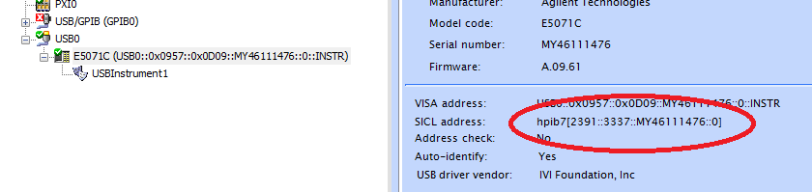

LCR Meter Address
The GPIB address for the LCR meter, used for Low Frequency measurements. 13 is the default value.

RF Switcher Address
GPIB or RS232 address for the RF switcher. (for RS232, 1 is the default for COM1)

LF Switcher Address
GPIB or RS232 address for the Low Frequency switcher. (for RS232, 1 is the default for COM1)

LF Switcher Type
The LF Switcher type used to connect the cable to the LCR Meter for Low Frequency measurements.

Switch Setup
When this option is set to STANDARD, the system operates as a regular Near and Far end system. However when set to NEAR END, the system will operate as a near end only system. This would effectively change a 4-pair system into an 8-pair near-end only system. For example, when in this setting, if you wanted to test NEXT on a 6-pair cable using the 4-pair system, you could hook the cable up as follows:

1N - Near End Cable Pair 1
2N - Near End Cable Pair 2
3N - Near End Cable Pair 3
4N - Near End Cable Pair 4
1F - Near End Cable Pair 5
2F - Near End Cable Pair 6

The far end of the cable would be terminated in 100 Ohms.

You will then be able to test NEXT fully automatically on a 4-pair system using this method.

LF LCR Meter
The low frequency LCR meter currently connected to the system. If no LCR meter is being used then Disabled should be selected, otherwise the only currently supported meter is the 4263. This is compatible with either the A or B model, but it must have option #001 for DC measurements enabled on it.

Manual Switching
The manual switching method used by an Automatic system. If there are no additional manual connection options, 2N->Port1 1N->Port2 should be used.

Un-calibrated Loss at 1MHz
This is the un-calibrated loss on the network analyzer at 1MHz. To check what this value should be, run a continuity test on the thru cable, the value displayed is the Loss. The default is -1.5, this should be used for most systems. The only time this would need to be changed is in the event of a custom system configuration with much more cabling or additional switching after the balun

Decimal Point Precision
This allows the precision of the results to be specified. Any value between 0 and 11 can be set. 3 is the default, this would display and limit check results to 3 decimal places, for example: 103.436.

System Configuration

The following options can be configured from the System Configuration section:

Calibrations
The directory path where the Calibration files are to be stored. (can be any local or network drive)

Instrument Setup Files
The directory path where the Instrument Setup files are to be stored. (can be any local or network drive)

Test Sequences
The directory path where the Test Sequence files are stored. (can be any local or network drive)

Limit Line Masks
The directory path where the Limit Line files are to be stored. (can be any local or network drive)

Product List
The directory path where the Lists are to be stored. (can be any local or network drive)

Specification Files
The directory path where the Specification files are to be stored. (can be any local or network drive)

Prompt Files
The directory path where the Prompt files are to be stored. (can be any local or network drive)

Log Files
The directory path where the Log files are to be stored. (can be any local or network drive)

System Identity
Stores the name of the current system for trace-ability of results. (e.g. Production1, Lab, R&D etc.) This is particularly useful where more than one test system is being used, and the results for each one need to be traced.

File Logging
Logs details of testing, calibrations and editing details of every cable test file for complete trace-ability.

Language
The language to be used for the full range of system prompts, menu items and button controls. Available languages are: English, French, German, Mandarin, Simple Chinese and Korean. English is the default. The translation files are stored in the C:\CableTest\ directory under the filename Ln.nfo, where n is the number of a language. It is recommended that these files are not changed, but they can be modified with caution.

Logon Configuration

The following Logon options can be configured:

Auto Log-off After test
Forces the system to automatically log-off the current user at the end of a test.

Shift Entry
Prompts for the user to enter a shift number at logon.

User Name Required
Specifies if the user name should be entered at logon. If system security is an issue, this option should be enabled.

User Entry Configuration



The following User Entry options can be configured:

Remember Settings
When set to Enabled, the user entry fields from the last test will be inserted into the fields automatically at the start of every test. If set to Disabled, the fields will be left blank.

Temperature Entry
Allows a temperature value to be entered in either °C or °F prior to testing, and applies a compensation algorithm to the Attenuation and DC Resistance tests.

Length Entry
Specifies the format to use for entering the cable length, this can be set to either Feet or Meters.

Post-Test Comments Entry
Allows a post-test comments entry screen to displayed at the end of every set of tests, and the comments stored in the results file.

(The following 3 items are repeated 10 time in the system properties to allow up to 10 user entries to be specified.)

Parameter n Name
The name of the user entry parameter required before testing. This should be left blank if no entry is required for this field. If the | symbol is inserted after the parameter name, it allows the default entry to be supplied (eg: Batch Num|1081). Drop down menu boxes can also be used. To configure this setup the entry name, and then list all the multiple-choice selections separated by the ‘|’ character. Eg: ‘Country of Origin|USA|UK|China|Japan’.

Parameter n Min Chars
The minimum number of characters required by the user entry parameter. (0 means it can be left blank)

Parameter n Max Chars
The maximum number of characters required by the user entry parameter.

Test Configuration

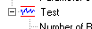

The following Test options can be configured:

Number of Re-tests
The number of times the operator will be allowed to re-test a failure.

Valid Cal (Days)
The length of time in days for which a calibration will remain valid. (Setting this to 0 means the calibration never expires)

Pause After Every Test
When enabled, the system will be paused after every test to allow results to be viewed.

Calibration Expiry
What the system will do when a calibration expires. Either prevent further testing, or display a warning.

User Configurable Equations
This is an advanced software feature that is disabled by default. When enabled, it allows the algorithm used to calculate selected tests to be modified. A new entry box will be displayed in the specification file, and the default algorithm can be overwritten with any formula required.

Auto Next Test
At the end of a test, forces the same cable type to be tested with the operator entry screen containing the same information.

Transmission Curve Fitting
When enabled, allows transmission measurements (IL, Delay & VOP) to be smoothed to compensate for the ringing affects seen when using 1-port analyzers. The default value is DISABLED.

Cable Connection Screen
Determines if the connect cable message should be shown at the start of a test. This option should only be disabled if the same pair colours are always used.

Product Naming Convention
The name used to identify products to the user. (i.e. Product, Part, Cable Spec etc.)

Far End Testing
Enabled for far end testing. This option should only be disabled for basic systems that do not have far end switching capability.

Cal Open Name
The name used to prompt the user to connect an Open standard to the system. For example, if coloured standards are being used a colour can be entered.

Cal Short Name
The name used to prompt the user to connect a Short standard to the system. For example, if coloured standards are being used a colour can be entered.

Cal Load Name
The name used to prompt the user to connect a Load standard to the system. For example, if coloured standards are being used a colour can be entered.

Return Loss Calculation Method
Specifies how Return Loss is calculated. STANDARD uses the Impedance (20*Log10[Impedance-100/Impedance+100]). COMPLEX uses the Real and Imaginary S11 data to calculate Return Loss (20*Log10[SqrRoot[S11Real^2+S11Imag^2]]). The affects of this are described in more details in the Test Definition section of this manual.

Results Configuration

The following Results options can be configured:

Directory Path
The directory path where the Results are to be stored. (can be any local or network drive)

Sub Directory 1
The first sub directory path, below the main results directory.

Sub Directory 2
The second sub directory path, below the main results directory.

Sub Directory 3
The third sub directory path, below the main results directory.

Sub Directory 4
The fourth sub directory path, below the main results directory.

Sub Directory 5
The fifth sub directory path, below the main results directory.

Filename
The main filename used to store the results.

Filename Extension
The filename extension used to store the results. This can be either:
.txt
.000
.csv

Filename Exists
The action to take if the filename already exists. Either derive a new filename from the date and time, an extension of 000-999, or overwrite the existing file.

Result File Format
Defines the structure for the result file. This can be set to either the default TAB delimited, or Comma delimited. Comma delimited allows easier importing into Microsoft Excel.

Store R+jX Results
When Enabled, the Real and Imaginary results will be stored in addition to the normal results in a tab-delimited text file using the format 'filename (R+jX).ext'

Applications Configuration

The following Application settings can be configured:

Custom Reporting
Operation of the custom reports. AUTOMATIC loads the reports automatically after every test, ENABLED allows the reports to be optionally selected. AUTOMATIC (UNLESS ABORTED) means the reports will always be loaded, unless the test was aborted.

Report Exe Path & Name
The full path and filename of the Report application.

Quality Statistics
Operation of the quality statistics. AUTOMATIC stores the statistics automatically after every test, ENABLED allows the statistics to be optionally stored.

Statistics Package Path & Name
The full path and filename of the Quality Statistics application.

EDIT USERS

Edit Users Overview

The user form allows user details to be setup for all people who will use the system. The varying degrees of access are described below. The user file is always stored on the local machine under the ‘C:\Windows\’ directory, in the filename ‘HPTest Users.Usr’, and is stored as a Microsoft Access 2000 database file.

To edit the users, from the main menu, select System Setup, then Edit Users.

Selecting Edit Users

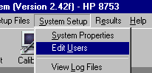

A list of the current users will be displayed, along with their passwords and user levels.

Example User File

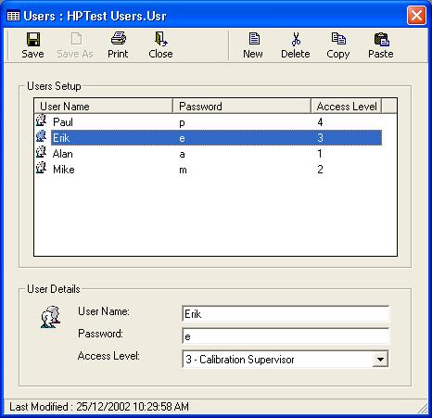

User Levels

The user name and password are required to login to the system. 4 User levels are provided as follows:

Level 1 – This is the most basic user level. The user can only run tests, and view previous results.

Level 2 – This is a slightly more advanced user level. The user can run tests, view results, and (if configured) select a cable product to test.

Level 3 – This level is considered to be a supervisor level. The user can run tests, and perform system calibrations.

Level 4 – This is the highest level on the system, the system manager level. This level can perform all the capabilities of the previous levels, but also configure the system, setup users, and configure test setups. It is important that users with this level are competently able to make changes, as it is possible to ruin the setup of the system.

INSTRUMENT SETUP FILE

Instrument Setup Overview

The instrument setup file is selected from the Test Setup Files, Instrument Setup menu items.

Selecting Instrument Setup file.

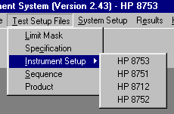

From within this menu you have to select the analyzer type connected to the system. Each instrument setup file will relate to a separate analyzer and have a separate calibration file associated with it. The data contained in this file specifies the instrument setup for the tests being run.

The filename can be any valid Windows filename (up to 256 characters).

Example Instrument Setup File.

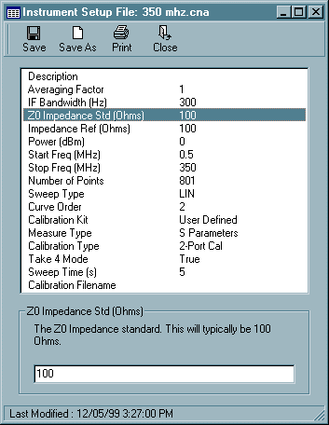

Instrument Setup Options

The following options can be specified from this screen:

Description
Allows a textual description of this file to be stored.

Averaging Factor
Takes the average of several sweeps to reduce the amount of noise.

IF Bandwidth (Hz)
The IF Bandwidth setting lowers the noise floor of the system.

Z0 Impedance Std (Ohms)
The Z0 Impedance standard. This will typically be 100 Ohms.

Impedance Ref (Ohms)
The impedance reference value. Used in measurement calculations.

Power (dBm)
The test port power level used by the analyzer in dBm.

Start Freq (MHz)
The sweep start point in MHz for the analyzer to sweep from.

Stop Freq (MHz)
The sweep stop point in MHz for the analyzer to sweep to.

Number of Points
The number of points used in the sweep (between 3 and 1601).

Sweep Type
The type of frequency sweep used, either Linear or Logarithmic.

Curve Order
The starting curve order used for calculating fitted test results. (a 2nd order is set as the default). If this value is surrounded by parenthesis, the curve order will not be lowered automatically (as specified by the ASTM requirement). Eg: (2). This can be useful if you are sweeping out further than the sweep would normally be required, and spikes or noise is affecting the natural curve fit.

Calibration Kit
The calibation kit to use. The user defined kit has been defined by HP.

Measure Type
Method of retreiving measurements, either once or as 4 S-Params. For the best possible accuracy and speed it is recommended that this option is left set to S-Params.

Take 4 Mode
Allows 4 sweeps to be read at once. This feature is only included on the 8753E model, and needs to be set to 'False' for all other analyzers.

Sweep Time (s)
Sweep time can be increased if required. 0 is the default and allows the fastest sweep speed as determined by the analyzer. This only needs to be lowered if there are problems with the analyzer sweeping too fast for the cable being measured.

Calibration Filename
Allows a calibration file to be shared between multiple instrument setups. This is an advanced feature and should not be required for normal operation of the system.

SPECIFICATION FILE

Specification File Overview

The specification allows the test specifications to be defined. This is selected from the main menu from the Test Setup Files, Specification menu items.

Selecting Specification file.

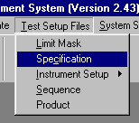

The specification file contains a limit for every test that the system is capable of running. The limits can be selected by clicking on the test name.

Example Specification File.

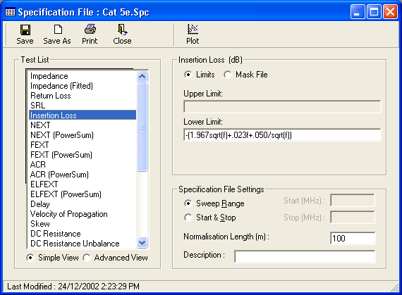

Simple View / Advanced View

This option determines how the limit data is displayed for editing. Simple View is the default, this allows one limit to be set for a number of tests, for example when the limit for Impedance is set, the same limit will be applied to Impedance Termination Near & Far, and Impedance Open/Short Near and Far. On the unlikely occasion when you would need different limits for these tests, you can select Advanced View. In the Advanced View mode, each test is listed separately and requires a separate limit entry.

Limit Entry

If the limit is derived from a formula (such as NEXT shown above) or a hard limit (such as impedance 100 +/- 15) then the option should be set to Limits. The mathematical limit can be directly typed into the entry box using standard math notation, The following section details the exact variables and functions supported.

It is also possible to use a limit mask file. This allows different limits to be setup at different frequency points. The process for setting this up is described in the next section. To select a limit mask file, click on ‘MaskFile’, then press the ‘Select File’ button to choose from the list of mask files available.

The button marked ‘Example Plot’ allows a test plot to be displayed containing the current limits, this is useful for checking that an equation has been correctly entered.

Math Facilities

The following variables can be used in the math expressions:

F - Frequency in MHz
DATA - Result data at the given frequency
INSERTION_LOSS - Insertion Loss data at the given frequency
TEMP - The temperature as entered at the start of the test
LENGTH - The cable Length in Meters
NOLIMIT - Do not perform any limit checking
MIN_RESULT - The minimum test result value
MAX_RESULT - The maximum test result value
MEAN_RESULT - The average test result value
SDEV_RESULT - The standard deviation of the test result
IL100_RESULT - The Insertion Loss at 100MHz
IL250_RESULT - The Insertion Loss at 250MHz
IL450_RESULT - The Insertion Loss at 450MHz
IL900_RESULT - The Insertion Loss at 900MHz
IL100_AVERAGE - The Insertion Loss at 100MHz (average of disturbed pairs)
IL250_AVERAGE - The Insertion Loss at 250MHz (average of disturbed pairs)
IL450_AVERAGE - The Insertion Loss at 450MHz (average of disturbed pairs)
IL900_AVERAGE - The Insertion Loss at 900MHz (average of disturbed pairs)
ILAVE_RESULT - The Average Insertion Loss over the entire sweep
INSERTIONLOSS - The actual Insertion Loss specification
NEXT - The actual NEXT specification
PSNEXT - The actual PSNEXT specification
PSELFEXT - The actual PSELFEXT specification

The following variables when used adds an extra selection box to the User Entry screen, to allow different cable specs to be selected, without needing a new file:

SOLID, STRANDED, STRANDED20, STRANDED50
TYPE1, TYPE2, TYPE3
GRADE1, GRADE2
LEVEL1, LEVEL2
SHIELDED, UNSHIELDED

The following function can also be used to allow more complex formula’s to be expressed:

IF ([Freq1] TO [Freq2] THEN [limit1] ELSE [limit2])

This is useful where a limit requires different algorithms over the frequency range, such as for the SRL limit. (In this case, it is also possible to use a limit mask file).

For Example:

IF(1 TO 20 THEN -23 ELSE IF( 20 to 100 THEN -16-10log(f/100) ELSE NOLIMIT ))

This equation would be interpreted as follows:

Freq: 1 MHz – 20 MHz, Limit: -23
Freq: 20 MHz – 100 MHz, Limit: -16-10log(f/100)
Freq: Any other frequency, No Limit

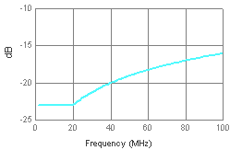

Additionally, the function BAND allows a similar facility to the IF statement to be used, but in an simpler way:

BAND ([Freq1] TO [Freq2] : [limit1] ~ [Freq3] to [Freq4] : [limit2])

You can have an unlimited number of : and ~ separators, in order to make very complex equations, for example:

BAND( 1 to 10 : 5 ~ 10 to 20 : 10 ~ 20 to 30 : 15 ~ 30 to 40 : 20)

Would look like this:

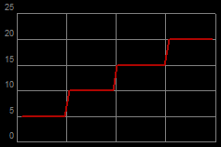

Also, instead of the TO statement, the frequency range can be expressed using < = > operators as follows:

1 <= f <= 10

Or

1 <= f < 10

To allow more control over the frequency ranges.

The following math functions are also supported:

Symbol Description Example

( ) Prioritizes an expression 5*(1+1) = 10
FACT Factorial fact(5) = 120
% Percentage 35% = 0.35
^ Raised to the power of 4 ^ 5 = 1024
* Multiply by 3 * 6 = 18
/ Divide by 9 / 2 = 4.5
\ Integer divide by 9 \ 2 = 4
MOD Modulo (remainder) 7 mod 4 = 3
+ Add 1 + 1 = 2
- Subtract 9 - 5 = 4
> Greater than 9 > 2 = 1
< Less than 7 < 4 = 0
== Equal test 5 == 4 = 0
>= => Greater or equal 3 >= 3 = 1
<= =< Less or equal #h3E <= 9 = 0
<> Not equal #b10101 <> 20 = 1
NOT Bitwise NOT NOT(15) = -16
AND Bitwise AND #b101 AND #h1E=4
OR Bitwise OR 13 OR 6 = 15
XOR Bitwise Exclusive OR 9 XOR 3 = 10
EQV Bitwise Equivalence 6 EQV 9 = -16
IMP Bitwise Implication 1 IMP 5 = -1
MIN Minimum value min(10,3,27,15) = 3
MAX Maximum value max(1,9)=9
SIN Sine sin(pi) = 0
COS Cosine cos(pi) = -1
TAN Tangent tan(pi) = 0
ASIN Arc sine asin(1) = 1.570
ACOS Arc cosine acos(-1) = 3.141
ATAN Arc tangent atan(0) = 0
SEC Secant sec(0) = 1
CSC Cosecant csc(1) = 1.18
COT Cotangent cot(1) = 0.642
SINH Hyperbolic sine sinh(3) = 10.01
COSH Hyperbolic cosine cosh(2) = 3.76
TANH Hyperbolic tangent tanh(1) = 0.76
COTH Hyperbolic cotangent coth(1) = 1.31
SECH Hyperbolic secant sech(0) = 1
CSCH Hyperbolic cosecant csch(1) = 0.85
ASINH Hyperbolic arc sine asinh(2) = 1.44
ACOSH Hyperbolic arc cosine acosh(9) = 2.89
ATANH Hyperbolic arc tangent atanh(.1) = 0.10
ACOTH Hyperbolic arc cotangent acoth(7) = 0.14
ASECH Hyperbolic arc secant asech(.3) = 1.87
ACSCH Hyperbolic arc cosecant acsch(2) = 0.48
ABS Absolute value abs(-8) = 8
EXP e to the power of exp(3) = 20.08
EXP2 2 to the power of exp2(3) = 8
EXP10 10 to the power of exp10(3) = 1000
LN Natural log ln(16) = 2.77
LOG2 Log base 2 log2(8) = 3
LOG Log base 10 log(100) = 2
CEIL Round up ceil(6.2) = 7
RND Random number rnd(1) = .969
INT Truncate to an integer int(6.8) = 6
SGN Sign of expression sgn(-9) = -1
SQRT Square root sqrt(64) = 8
CURT Cubed square root curt(10) = 2.15

Limit Checking Start & Stop

This option determines over what frequency span the limits are applied. This only applied to limit values entered directly, and not those created from a mask file. When Sweep Range is set, then the limits are applied to the entire frequency range, for example, if the analyzer were set to sweep from 0.772MHZ to 350MHz, the limits would be applied from the start to the stop frequency. If you wanted to restrict the frequency range being checked, click on Start & Stop, and enter a forced start and stop frequency in the frequency boxes, for example, you may want to limit check to start at 1MHz and stop at 300MHz, but still wish to see the results past these frequencies.

The complete set of EIA/TIA, ISO 1181 and NEMA standards are pre-configured in the specification directory, under normal operation, the specifications can be left pre-configured. You will only need to change these if there is a modification to the standard, or you require some unusual or highly specific types of testing.

Advanced Math

This is an advanced feature that must be enabled before use. To use, from the System Properties, select Test, then User Configurable Equations, and set this to Enabled.

When enabled, this allows the equations used to derive the test results, to be overwritten or customized on selected tests. An example is shown below.

Example Test Calculation:

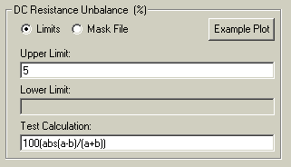

In this example, the standard method of calculating DC Resistance Unbalance, is being overwritten by a new formula. The variables available for each test (in this example a and b) can be found in the Test Definitions section in this manual.

If you want to check that the equation is functioning correctly, double click in the box; this will bring-up a drop down menu, double click Check Calculation from this menu. The software will then prompt you to enter enable values to put through the equation. For example in the case of a DC Resistance equation, the software would ask for 2 resistance values, in the case of Insertion Loss temperature compensation, the software would ask for a temperature value. The result will then be displayed for the entered data. Given the importance of this equation, we recommend that you always check them before using for real testing.

Please note, we recommend that extreme caution is used when modifying equations as it will completely change the way tests are processed.

Additionally, depending on the test, a dis-regard equation entry can be specified here, as shown in the following screen-shot:

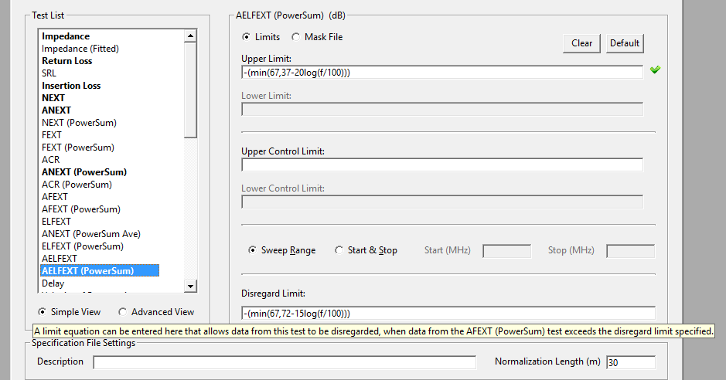
This allows data to be disregarded for limit checking purposes, when the data from another related test exceeds the limit specified.

To disregard any trace with an average of over 90db, use the following equation: Data - (-90 - AVERAGE_100_250)

To modify an Impedance measurement, the following commands can be entered: MEAN_RESULT, SDEV_RESULT. These will overwrite the Impedance results with either the Impedance mean or standard deviation.

Normalisation Length

The normalisation length allows the default length (100 Meters) to be overwritten. This allows any test that uses normalization to be calculated to a different length. For example, Attenuation is calculated as follows:

Normalised Attenuation = Attenuation * (x / Cable_Length)

Where x is the normalization length.

Entering a value for the normalization length will change the value of x.

If a value of zero is entered, no length normalization will be performed on the results.

Example Plot

To view an example plot of the current specification, click the plot button at the top of the window.

The plot will be displayed in a separate window (as shown below). Different axis, start and stop frequencies can be viewed to check the algorithm is correct. Double-clicking on the graph itself will change the display to show the frequency points at a number of discrete frequencies.

Example Plot

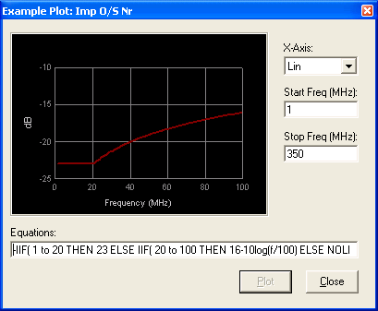

Limit Checking

When a specification file is saved, all the algorithms are checked to ensure there are no obvious problems. If any problems are found, a message box indicating the problem is displayed as shown below.

Example Specification Check Message

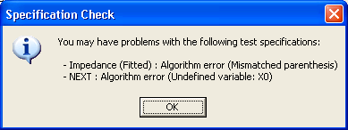

LIMIT MASK FILE

Limit Mask File Overview

A limit mask file is used where a limit cannot be specified using just an equation. This option is selected from Test Setup Files, Limit Mask from the main menu.

Selecting Limit Mask File.

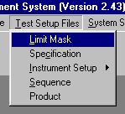

The limit mask file shown below shows a limit, where an equation is used to generate the first part and the last part of the limit. The section between 10 and 20 MHz is a flat line.

Example Limits File.

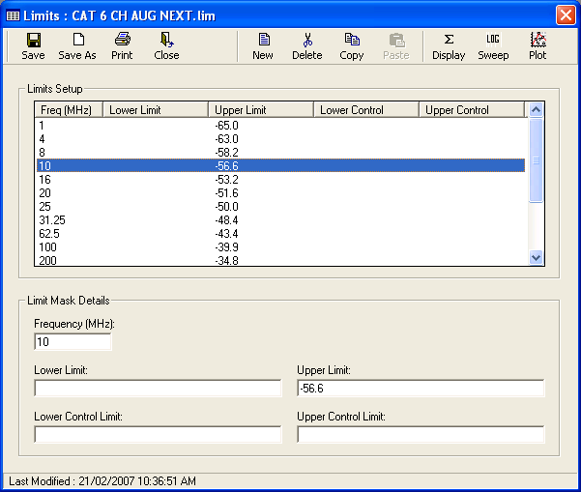

The button labeled Sweep is used to specify if hard drawn lines are plotted as Lin or Log. This is only needed where equations are not used such as in the above example where each frequency point is specified.

The Example Plot button allows a test display to be plotted to let the user check that the equations have been correctly entered.

Example plot facility

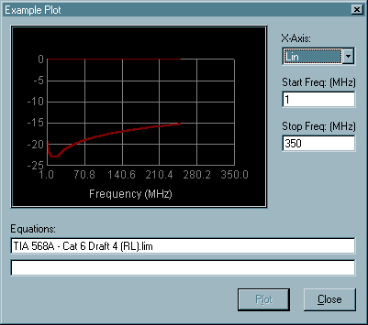

Sub Equations

SEQUENCE FILE

Sequence File Overview

The sequence file defines what tests are to be run, in what order, using what instrument setup and to what specifications. To select option, click on menu items Test Setup Files, Sequence.

Selecting Sequence File.

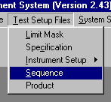

The sequence file is displayed in the main grid. A list of test numbers are shown on the right hand side of the screen. The editing functions Cut, Copy, and Paste, refer to a separate line of the main grid.

Example Sequence File

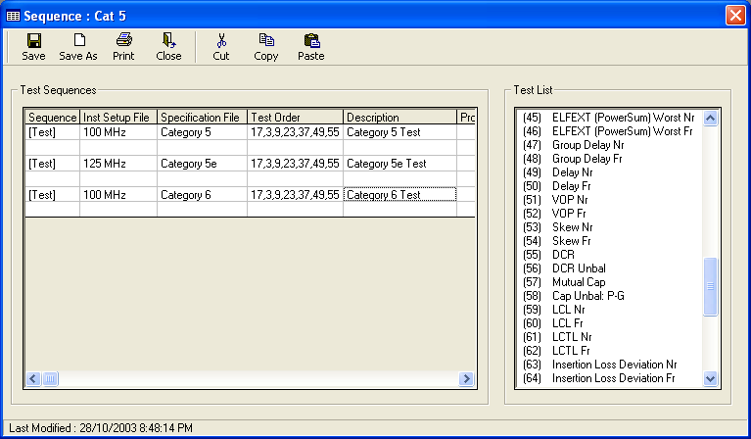

The fields to be configured are described in the following sections.

Sequence

This field contains a keyword to identify the operation to perform on this line of the sequence file. Double-clicking the mouse in this cell will display a list of keywords. Valid keywords are:

[Test]
This identifies a new line in the sequence. When this sequence file is selected, the description for this line will be displayed for the operator to select.

[Then]
This identifies that the sequence on this line follows on from a [Test] sequence. This allows tests to be run using different analyzer or specification setups within the same sequence. An example of using this facility is shown on the display above.

[If Pass Then]
This facility is similar to the [Then] feature, but means that this line of the sequence will only be run if all previous tests have passed.

[If Fail Then]
This facility is similar to the [Then] feature, but means that this line of the sequence will only be run if none of the previous tests have failed.

[If Prev-Line Pass Then]
This facility is almost identical to the [If Pass Then] keyword, with the exception that it only applies to the previous line in the sequence, not the whole test.

[If Prev-Line Fail Then]
This facility is almost identical to the [If Fail Then] keyword, with the exception that it only applies to the previous line in the sequence, not the whole test. A useful application of this feature would be for testing a cable to different specs only if it fails the higher spec, for example, a cable could be tested to Cat 5, if it fails then tested to Cat 4, if it also fails, then tested to Cat 3.

[If Yes Then]
This facility will force a selection box to be displayed on the screen. The operator will be asked if they want to run the tests on this line ‘Yes’ or ‘No’. This line of the sequence will only be run if ‘Yes’ is selected.

Instrument Setup File

The Instrument Setup File being used for the current tests should be specified here. Double-clicking in the cell brings-up a file select box with the full list of Instrument Setup Files available. Different lines in the test sequence can be configured to use different Instrument Setup Files, for example, as shown in the print-out above, this would allow some tests to be run on a Log Sweep and others using a Linear sweep.

Specification File

The current Specification File being used should be specified here. Double-clicking in the cell displays a file selection box with the available Specification files. The selected Specification file specifies what limits the tests on that line will be tested against. Different lines in a sequence can be configured to use different Specification files, for example, you may want to setup to test against Cat 5, Cat 4, and Cat 3 limits.

Test Order

The sequence of tests (in the order they are to be run) should be specified here. The test order is entered by listing the numbers, separated by commas. The full list of available tests is shown in the list box on the right of the screen. The test numbers can either be typed in manually, or double-clicking on the test names in the box will add the appropriate number and comma into the current cell. It should be noted that the tests will be run in the explicit order specified here, so for ease of connection it can save time to put the Open/Short tests at the end of the list to save re-connecting the cable after making the measurement. It is also good practice to put the Low Frequency measurements after all the RF tests, as this normally requires a separate connection.

Description

This entry contains the description for the current test sequence. When the operator selects a product using this sequence file, the list of descriptions is displayed for them to select from. Only lines prefixed with the [Test] keyword are allocated descriptions.

Prompt Files

Prompt files are used to provide extra instructions for the user during the test. The information will be displayed in a display box on the screen at the relevant point in the testing.

Double-clicking in this cell allows one or more prompt files to be selected. If you want to select a number of files, hold down the CTRL button when selecting each item. The files are stored in the prompt directory (specified in the system properties).

A typical prompt would consist of one text file (containing instructions for the user), and one or more picture files. Bitmaps of the following file extensions can be used BMP, JPG, JPEG and GIF. If more than one bitmap is selected, Next and Prev buttons are added to allow the various pictures to be displayed in sequence.

An example is shown below illustrating the procedure for setting this up using a picture Term.JPG and a text file, Near End Term.txt text file:

Example Sequence setup.

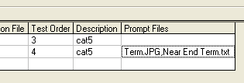

Example text file.

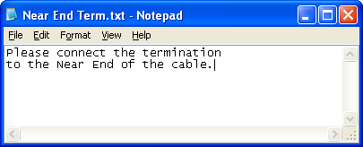

Example picture file.

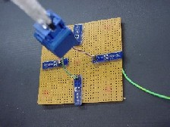

In-test prompt example:

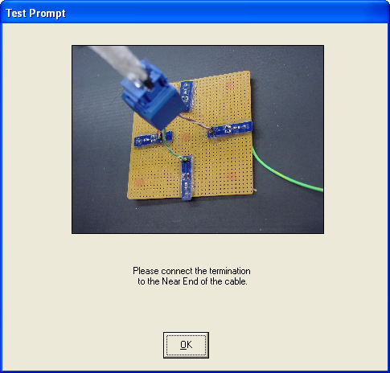

PRODUCT FILE

Product File Overview

To select the product file, click on Test Setup Files, Product, from the main menu.

Selecting Product File.

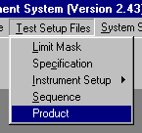

The product file contains information about each product to be tested and links it to a particular Sequence file. When an operator selects to run a new test, they first have to select a product file, then a product within that file.

Example Product File.

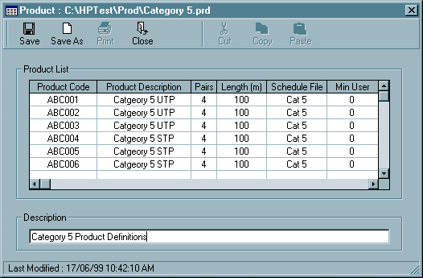

The following sections describe the fields that need to be configured within a product file.

Product Code

The product code would contain the internal product identification number used to identify a particular cable. At the start of a test, this product number (along with the description) are displayed in a box for selection by the operator.

Product Description

Each product code can be given an optional description which would be displayed at the start of testing.

Pairs

Specifies how many pairs are defined for the product, this can be any number between 1 and 200.

Additionally, the following options can be used in this box:

7x4 - To define a cable as an Alien type, you would specify the pair number as NumBundles x PairsInBundle, so a 6 around 1 cable would be specified as 7x4 for 7 bundles, and 4 pairs in each bundle. (You can also specify this as [28], which is in the software for backward compatibility).

(25) – If the number of pairs is surrounded by parenthesis, this tells the software that it is a standard bundled cable, for a 25-pair cable, where NEXT and Skew were to be tested only within their bundles of 4-pairs.

{25} - If the number of pairs is specified surrounded by ‘{}’ brackets, this will be tested as a regular cable with the exception that only NEXT combinations within each group will be limit tested, and Delay Skew will be tested within individual groups.

Length (m)

This entry contains the default length for this product in meters. At the start of the test, the default length is displayed in a text box, which can be overwritten by the operator with a different length if required.

Sequence File

The sequence file can be selected by double-clicking on this entry. The sequence file contains information about which tests to run on the selected product.

Min User

This entry contains the minimum user level that can test this particular product type. The default value is 0, meaning that any level of user can test it. Any value between 0 and 4 can be entered here. This feature would be used if there was a particularly difficult type of cable that required specalised training to connect, for example, you may want to make all 600MHz products only accessable to a level 3 (supervisor level) operators. If a lower level operator tries to test a cable which is higher than their level, a message will be displayed and they will be returned to the main menu.

Pair Colours

This specifies the core colours for pairs 1 to 200. They are used for operator prompts and data storage. It is only necessary to enter colours for the Pairs used, for example, for a four pair cable you may enter Blue, Orange, Green, Brown, under the Pair 1-4 entries and leave the other entries blank.

User Defined Tests

From the main menu, select the user defined tests menu, and enter a filename.

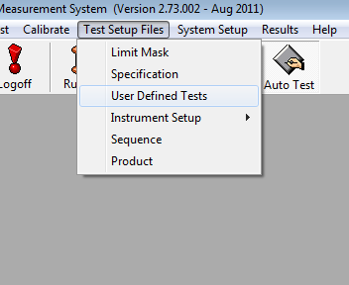

From here, the User Defined Test setup screen will be displayed.

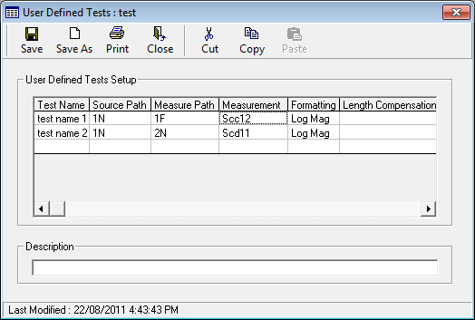

From this screen, pretty much any combination of test measurement and limit checking can be defined.

The following entries can be configured:

Test Name

This is a free entry field, and can be anything you like, used to describe what you are testing. This is how the measurement will be recorded in the result file. You can also use the variables %DefFileName%, %DefSubDirName%, %Measurement%, %SourcePath%, %MeasurePath% and %Formatting% here to reference the User Def filename, Measurement, and path names in the test title. Additionally, you can use the variable %ColourNameX% where X is a pair number. This allows the pair colour name defined in the product file to be used in the test name. The variable %Default% will create a measurement name based on all the parameters above, to create a unique measurement name.

Source Path

The Source path for the switcher. Double-clicking in this box will display the full list of available paths.

Measure Path

The Measured path for the switcher. Double-clicking in this box will display the full list of available paths.

Measurement

Double-clicking will allow you to select from the full range of 16 measurements available over your selected measurement path.

Formatting

The post measurement formatting to apply to the selected test. Double-clicking will bring-up the range of options available.

Length Compensation

Double-clicking in this entry will allow a choice of 2 types of length compensation method, or NONE to be selected.

Temperature Correction

This is a free entry field that allows a temperature correction value to be specified. For example, entering 0.22 here would apply a temperature correction factor of 0.22% to the results. If this entry is left blank, no Temperature Correction is applied to the results.

Other Math

This allows extra post process math to be performed on the data. Any free entry math expression can be entered here, using the following variables:
RESULT – References the actual results taken with that sweep
Sxxxx_yy_xx – Where:
xxxx is a set of S-parameters (Sdd12 etc, or S__ for single core)
yy is a Source path
zz is a destination path.
T:’test name’

Examples of how these variables can be used are shown below:

A TCL measurement may use the following math to add 2db onto the results as requested in the standard:

RESULT+2

An ELFEXT measurement may be defined as follows:
RESULT + Sdd12_1N_1F

A single core Skew measurement might be defined as follows:

Max(T:'Delay 1Na',T:'Delay 1Nb',T:'Delay 2Na',T:'Delay 2Nb',
T:'Delay 3Na',T:'Delay 3Nb',T:'Delay 4Na',T:'Delay 4Nb') –
Min(T:'Delay 1Na',T:'Delay 1Nb',T:'Delay 2Na',T:'Delay 2Nb',
T:'Delay 3Na',T:'Delay 3Nb',T:'Delay 4Na',T:'Delay 4Nb')

Upper Limit

This is a free entry field, and can be any equation or fixed value, to be used as the upper limit during testing. Any equation can be entered here, in exactly the same way, as for a regular spec file. If this field is left blank, no limit will be used. The variable ‘SAME AS ABOVE’ can also be entered here to indicate that the same limit should be applied, as the user defined test on the line immediately above.

Lower Limit

This is a free entry field, and can be any equation or fixed value, to be used as the lower limit during testing. Any equation can be entered here, in exactly the same way, as for a regular spec file. If this field is left blank, no limit will be used. The variable ‘SAME AS ABOVE’ can also be entered here to indicate that the same limit should be applied, as the user defined test on the line immediately above.

Limit Mask File

The filename of a limit mask file can be entered here, to be used for limit checking instead of an upper and lower limit. The variable ‘SAME AS ABOVE’ can also be entered here to indicate that the same limit should be applied, as the user defined test on the line immediately above.

Limit Link to Spec file

Double-clicking in this box will display a list of all the tests referenced in a specification file. You can select any test name from this list, and the limits used for this entry will be linked to that entry in the currently selected specification file. Eg: if Return Loss Near is selected, the limit from the Return Loss Near test in the specification file will be used. The variable ‘SAME AS ABOVE’ can also be entered here to indicate that the same limit should be applied, as the user defined test on the line immediately above.

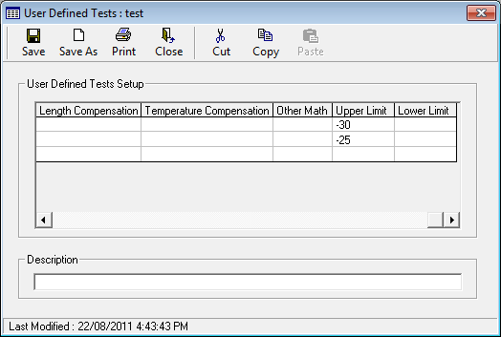

There is no limit on how many user defined tests you can define in a single file, and you can have many different files, to create whatever elaborate test structures and sequences you like.

When you have finished creating your list of user defined tests, you need to link these into the sequence file as shown below:

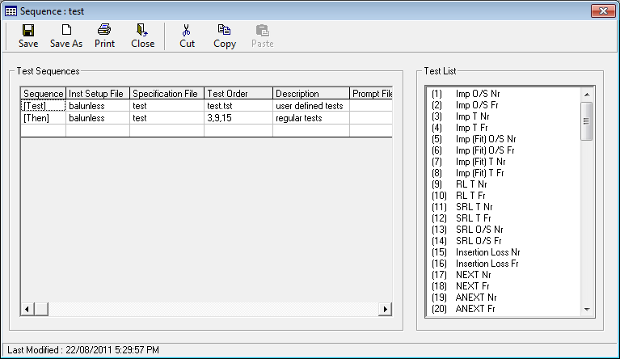

If you right-click the mouse when the Test Order box is shown, you will be able to select a user defined test file.

User-defined tests need to be entered on their own line within the Sequence file, so if you wanted to mix user defined tests, with conventional tests (ie: standard ISO/TIA requirements), you would need to put them on separate lines as shown in the example.

RESULTS

Results Overview

At the end of every test a full set of results are stored, listing every result at every recorded frequency point. These are stored as ASCII Tab-Delimited for maximum compatibility with other packages.

The location of the results file is configurable in the system properties (described in section 3.7) this allows the system manager to decide on the format and structure for the filenames and directory paths.

At the end of a test, when you have been returned to the main menu, there are a number of options you can use. Selecting Results, Last Test, will display a list of options that can be performed on the result file last tested.

Selecting View as Text option

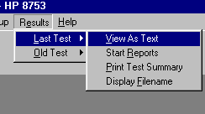

View As Text allows the user to load the results file from the last test into Microsoft WordPad for you to view. This can be viewed (and edited if required) in the same way as any regular document file. The format for this file is described in detail in the next section.

Start Reports allows the result file to be loaded up directly into the report software, in exactly the same way as at the end of a test.

Print Test Summary allows the test summary list displayed at the end of the testing process to be printed out.

Display Filename allows the full path and filename for the last test result file to be displayed in a text box. This can be useful if you are unsure exactly where it was saved.

All of the same options are also available for previously tested results by selecting Old Test. The only difference is that a file selector will be displayed to allow the user to choose the results to be displayed.

Functions available on previously tested results

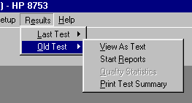

There is an additional option in the system properties, under Results, Store R+jX results. When enabled, this allows a separate results file to be stored which contains all the Real and Imaginary results, and all four sets of S-Parameters for each test. This is disabled by default, but can be useful for calculating advanced mathematical data from the results.

Results Format

An example results file is shown below:
TEST REPORT (2.20)

SYSTEM :
Analyzer HP 8753
Identity Production

OPERATOR :
Name Bobby
Level 4

PRODUCT :
Description Category 5 UTP
Type Balanced
Product ABC001
Batch No 001
Serial No XYZ
Cable Length(m) 100
Pairs 4

TEST SCHEDULE :
Test Schedule File EIA-TIA Cat 5
Test Started 14/06/99 6:54:37 PM
Test Description Standard Category 5 Tests
Run Mode AUTO
Temperature 24

OPERATOR COMMENTS :
Pre-Test Comments Any additional operator comments can be added here.

RESULTS FILE :
Results C:\HPTest\Results\001\XYZ\ABC001.txt

TEST SETUP:
Instrument Setup File 100MHz.cna
Start Freq (MHz) 1
Stop Freq (MHz) 100
Points 401
Sweep Type SWEEP
Sweep Mode LIN
Power Level(dBm) 0
Averaging 1
IF Bandwidth(Hz) 1000
Normalised Impedance(Ohms) 100
System Impedance(Ohms) 100
Sweep Time 0
Calibration Filename 100MHz.caa
Calibration Date&Time 08/06/99 6:14:50 PM
Specification EIA-TIA Cat 5

TEST: Attenuation Near

Point Freq Blue Orange Green Brown Lo Lim Hi Lim Pass/Fail

1 1.0000 -143.56E-02 -143.79E-02 -141.32E-02 -147.30E-02 x x PPPP
2 1.2475 -272.40E-02 -277.19E-02 -280.90E-02 -281.52E-02 x x PPPP
3 1.4950 -364.22E-02 -364.09E-02 -362.16E-02 -360.24E-02 x x PPPP
4 1.7425 -431.00E-02 -436.86E-02 -430.67E-02 -429.73E-02 x x PPPP
5 1.9900 -497.04E-02 -498.65E-02 -496.30E-02 -499.88E-02 x x PPPP
6 2.2375 -547.39E-02 -548.08E-02 -548.46E-02 -553.61E-02 x x PPPP
7 2.4850 -606.94E-02 -608.92E-02 -605.87E-02 -608.42E-02 x x PPPP
8 2.7325 -661.71E-02 -661.68E-02 -662.21E-02 -653.70E-02 x x PPPP

The body of the results file then contains the measured data against each frequency point. At each point retrieved from the Analyzer, there is a point number, frequency, data value, upper & lower limit and a pass fail flag. The results are in tab delimited columns which allows easy export into other applications such as Microsoft Excel. The columns are produced in the order in which the tests are performed. Each section contains the data from one instrument setup file.

SYSTEM OPERATION

Measurement Procedure

The following instructions describe the typical measurement procedure for initiating an automatic test on a cable:
- The operator Logs-On to the system by entering their name and password.

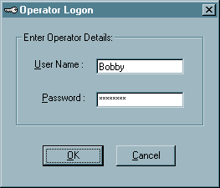

- The Run Test icon is selected.

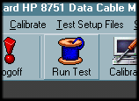

- The Product file to be tested is selected.
(Please note, if there is only one product file, this screen will not be displayed)

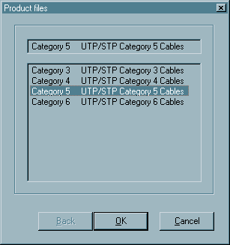

- The Product code, contained within the product file is then selected.
(Please note, if there is only one product contained in the product file, this screen will not be displayed)

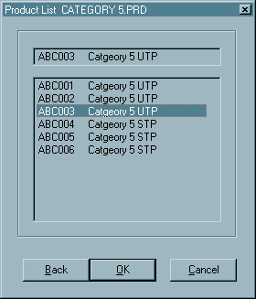
- The test sequence required can then be selected.
(If only one test sequence is setup in the file, this screen will not be displayed)

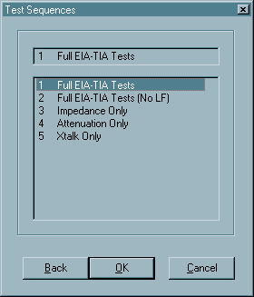

- The operator entry screen is then shown. This allows information about the current cable being tested to be entered. Clicking on Cal Expiry will show the expiration dates for all calibration files used in the current test. Double clicking on either the Length or Temperature titles will change the units between Meters/Feet and Celsius/Fahrenheit respectively. The Starting Pair option will be enabled if the system hardware has more than 4-pairs, this allows the cable to be hooked-up at any pair positions on the fixture, for example if a 4-pair cable was connected at pairs 5-8, the operator would set this to 5. This feature allows a second cable to be hooked-up while the first is being tested.
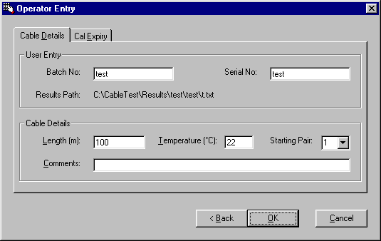

- The main test screen will then be displayed. The connect cable prompt will be displayed to indicate how the cable should be hooked up to the test fixture. Once the cable has been connected press OK.

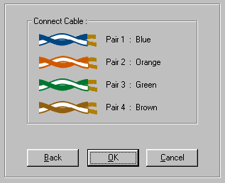

A continuity test will now be performed, to check that the cable is correctly connected (pressing S will Skip the continuity test at this point, additionally pressing D will force the following display to be shown, even if the continuity test passes).

If the system finds any problems with the cable connection, a screen will be displayed similar to the one below:

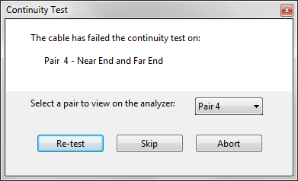

The first bad connection will be automatically be displayed on the analyzer screen, and any other pair can be selected using the drop-down menu.

If you are testing using a balun system, a simple display will be setup on the Network Analyzer showing when you have a good connection for that pair with a PASS/FAIL display.

With Balunless systems, we display more information is shown below. This is a good connection, the Near end Return Loss is shown in the 2 left hand boxes, and the Far end Return Loss in the right 2 boxes. The bottom box just gives a PASS for FAIL indication based on transmission between the near and far ends.

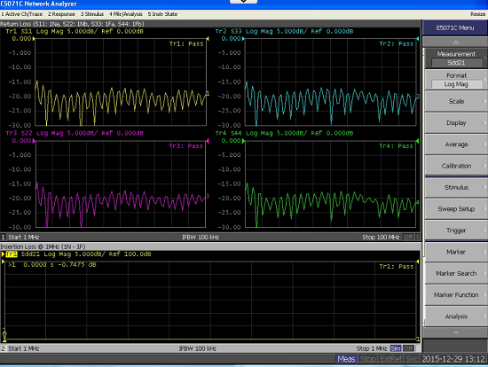

A bad connection would look something like the plot below. Note how S11 is correctly connected, but the hump in the results indicates the far-end is not correctly terminated (S44).

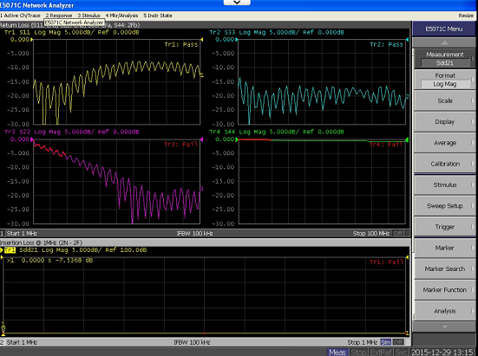

There is also a different display for Alien testing, as only the Return Loss traces need to be displayed. In this example, the connection at the far end (S33 and S44) is good, and the connection at the near end (S11 & S22) looks like it has not been terminated properly.

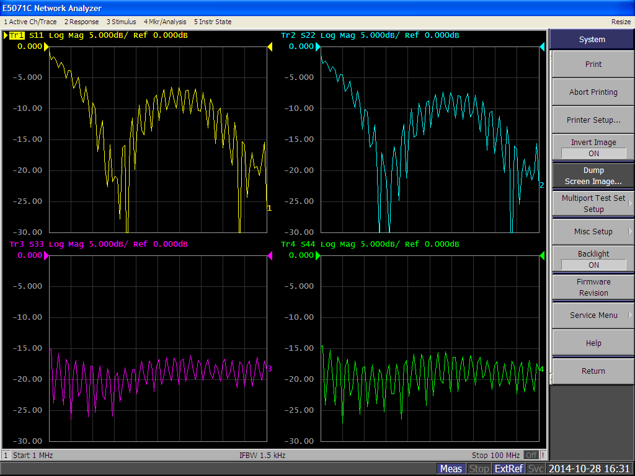

- After the continuity test, the measurements will then be run, with graphical results displayed on the screen. Depending on how the test system is configured, the execution of the tests may pause after each test or on a failure. If this happens, pressing Re-test allows the current test to be run again, and Cont allows operation to continue with the next test.

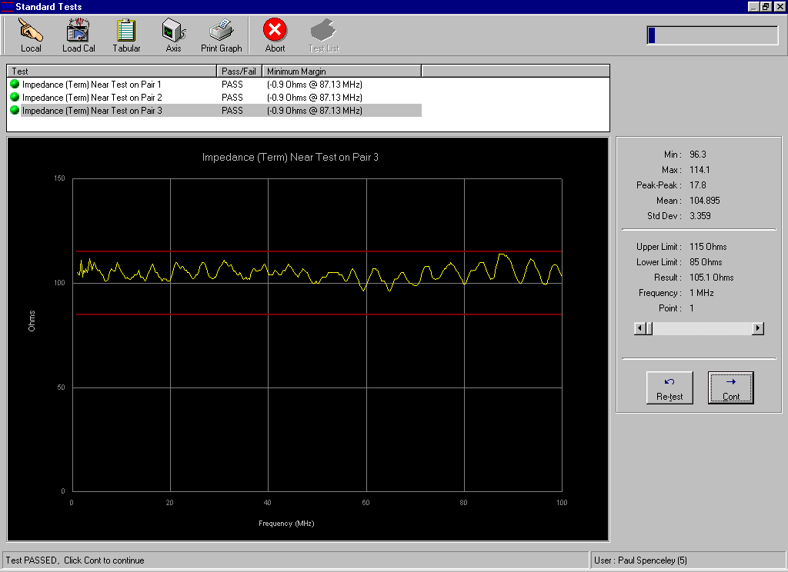

In the test, there are a number of toolbar buttons shown at the top of the screen, these can be used when a test is paused:

Local – Puts the analyzer into local mode, and starts it sweeping.
Load Cal – Loads the calibration for the current path into the analyzer.
Tabular – Displays a set of default ‘spot-frequencies’ for the current trace.
Axis – Changes the axis between Linear, Logarithmic and Square Root.
Print Graph – Prints the current graph, some spot frequencies and statistics.
Abort – Aborts the current test. (This can also be done by pressing the Escape key)
Re-test – Re-measures the current test.
Continue – Continue onto the next measurement.

Additionally, the following buttons can be used during a test:

S Skip continuity (skips the current continuity test)
C Connection info (displays the current connection information)
CTRL + S Switch control (opens the manual switch control window for
diagnostic purposes)
CTRL + C Calibration screen (displays the calibration data for diagnostic
purposes)

- At the end of the test sequence, a summary of all the tests will be displayed, and a Pass or Fail indicator to show the overall test status. Pressing Close will exit from this test screen.

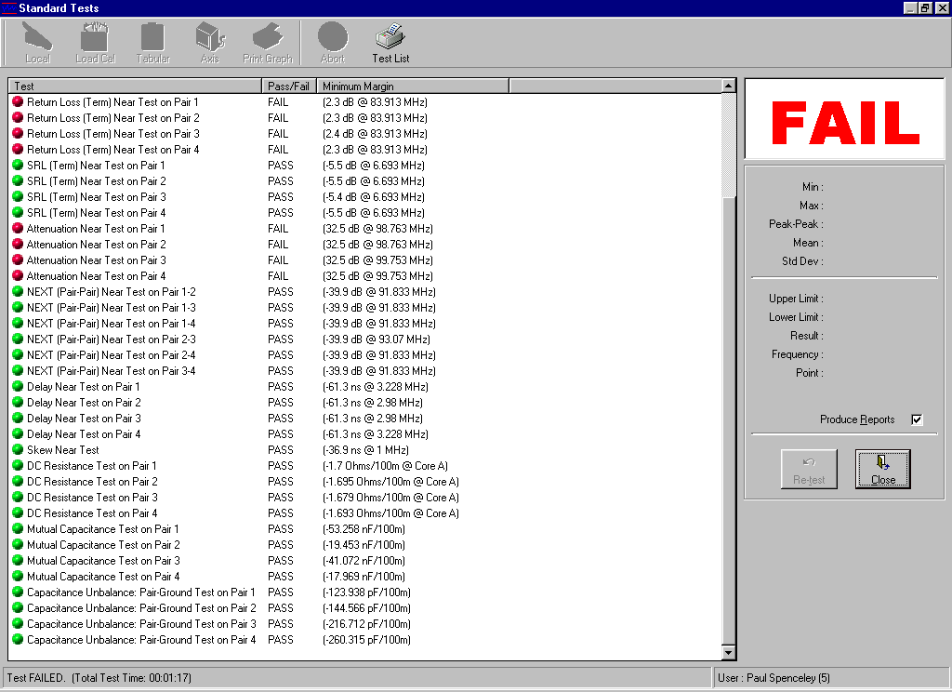

Two additional menu buttons are shown at the end of a test:

Test List – Prints a copy of the full test with some basic header information.
Close – This is the same as pressing the close button, and closes the window.

Clicking on any item in the test summary will display the graph from the test. Right-clicking will grey out the test line, and prevent that line from being printed if a print-out is selected.

- When the test screen has closed and the results have been stored, the Custom Report software will load. From this screen pressing Print will print-out all the custom reports available in the software.

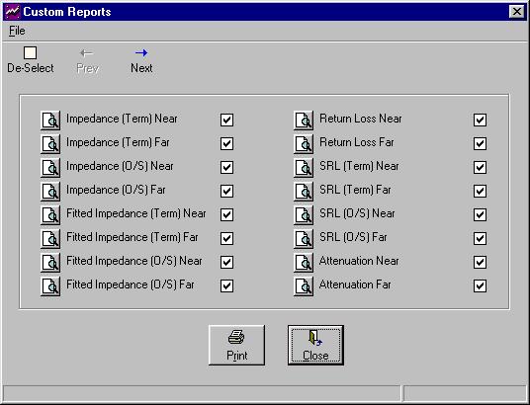

- The system will now return to the main menu and is ready to test another cable.

Test Configuration Summary

The previous sections have described the process of how to setup and configure the various files.

In summary, the following steps should be completed to configure a new test definition:

- Create a new specification file (use limit mask files if required)

- Create a new Instrument Setup File

- Create a new Sequence file for the tests required, and select the Specification File and Instrument Setup in the appropriate sections of the Sequence file.

- Create a new Product file, and include a link to the sequence file within this.

- The test definition should now be complete. Once the instrument Setup file has been calibrated, the system will be ready for testing.

RF CALIBRATION

RF Calibration Overview

A calibration is required for every instrument setup file. A test cannot be run unless a calibration has been performed for the instrument setup file referred to in the test sequence file.
Calibrations are timed, dated and the user name is stored, so that when a test is run this information is displayed and a high-level user can assess whether a new calibration is required. The validity period of the calibration can be configured; this determines the maximum amount of time before a re-calibration is required. This feature can be configured by the system manage in the System Properties menu. The ability to set a warning or prohibit tests if a calibration is out of date can also be configured.

On the main menu Calibrate should be selected, either by clicking on the button, or by selecting Calibrate, Perform RF Cal, from the drop-down menu.

Selecting RF Cal Menu Option.

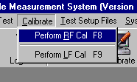

The system will then display a list of Instrument Setup Files for the currently selected Analyzer. If a calibration already exists for any of the files, the time, and operator name will be displayed after the filename, if a calibration exists but has expired, its expiry date will be shown. If the file is invalid (i.e. a major setting has changed such as the frequency range) then an invalid message will be displayed.

Example calibration selection screen

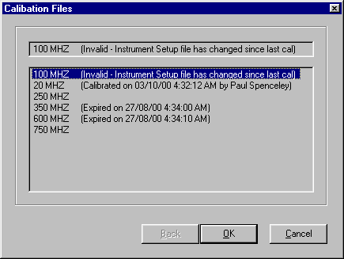
Calibrations are performed for all fixture positions in AUTOMATIC mode even if less than 4 pairs are being tested.
If the instrument Setup file has been edited since it was last calibrated, it will only remain valid if the following settings have remained unchanged:
Frequency start,
Frequency stop,
Sweep Type
Sweep mode
Power level
IF BandWidth

Once the calibration file been selected, the prompt window will display instructions to the operator for connecting the standards for a full calibration.

Balun Calibration

If a balun calibration is being performed, a screen similar to the one shown below will be displayed.
Calibration in progress
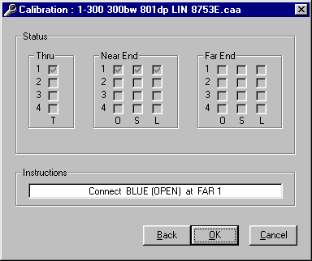
To perform the balun calibration, follow the onscreen prompts, and connect the standards as requested by the software.

Balunless Calibration

A number of different calibration options are available when using a Balunless setup.

Balunless Pair-at-a-time

This is the simplest Balunless calibration type (selected as ‘BALUNLESS’ in the instrument setup file). You select which paths you want to calibrate, and then connect the standards for each one in any order you like.

A typical screen for this is shown below.
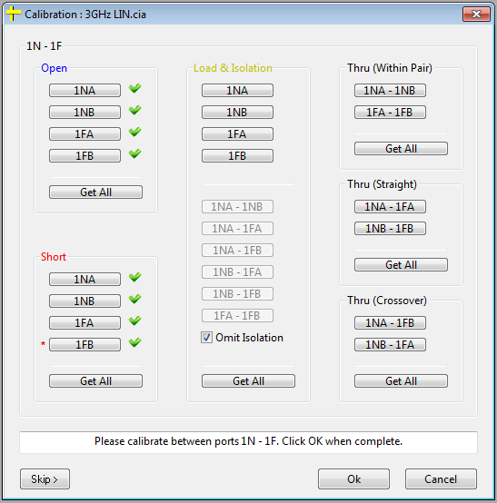

You also have the ability to leave out the Isolation part of the cal, but clicking the ‘Omit Isolation’ check box.

If you right-click any of the buttons, you can view that standard on the analyzer screen. This can be a useful tool, to ensure you have a good connection at the fixture prior to sweeping the analyzer.

Once all the standards have been measured, press ok calculate the cal co-efficients. When this has been completed, the ‘View Cal’ button will appear. It is highly recommended to use this, and view the calibration data to ensure it all looks good.

Balunless All-at-Once

This is a more advanced calibration method, but allows you to calibrate an entire fixture with much less human interaction required. It is selected as ‘BALUNLESS (ALL PATHS AT ONCE’ in the instrument setup file).

A typical initial screen is shown below.
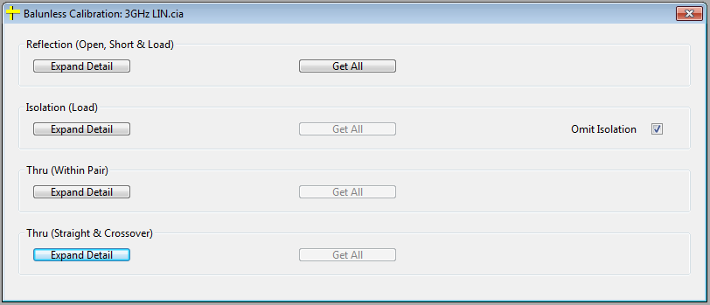

For the easiest calibration, just click Get All for each calibration stage, and let the software prompt you

If using the Get All button on the Thru (Straight & Crossover) section, you will be prompted to connect a particular Thru at both the near and far end. The software will then use these values for ALL paths. It should be noted, this is not the most accurate way to do it, but it saves a significant amount of operator connection time, and from our measurements, there is no real significant loss of performance from doing it this way. If you want to be absolutely 100% correct though, simply press the Expand Detail button, and go through all 28 sets of Straight & Crossover standards manually.

Right-clicking on any of the buttons, displays the graphs for that particular calibration, and right clicking on the green check icon allows that calibration data to be erased.

Balunless ECal

The Ecal option (Selected as ‘BALUNLESS (ECAL)’ in the Instrument Setup file) allows the system to be calibrated with the Ecal unit.

The calibration can either be run on every single path, or instead using the simplified cal, which allows the full calibration to be run using only 4 connections. Both calibration screens are shown below.

The additional cals button allows other instrument setups to be selected, and these can be calibrated at the same time, to reduce the number of re-connections needed.
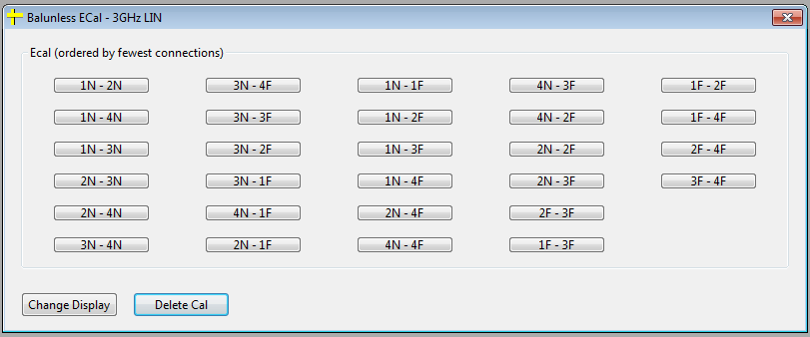

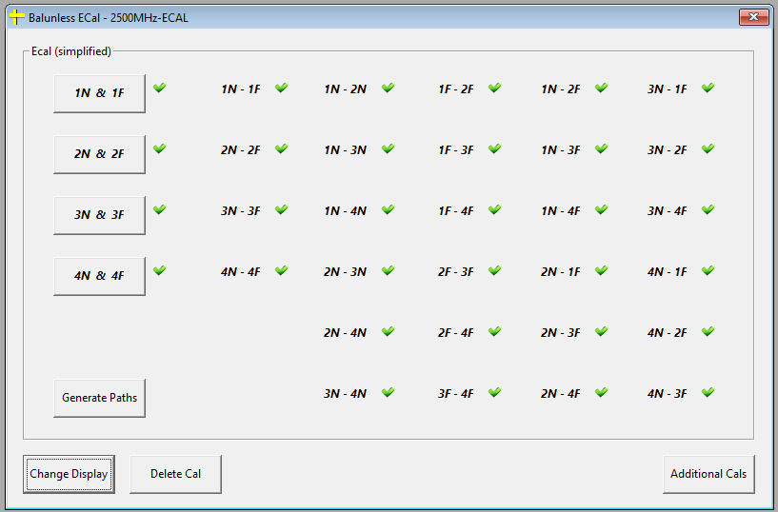

The simplified calibration works by compiling the new pairs from the data from the subset measured. For example, 1F-4F would be generated by combining the path data files 1F-1N and 4N-4F.

Thru Calibration

When the Thru cable is connected, the display on the analyzer should look something like this:

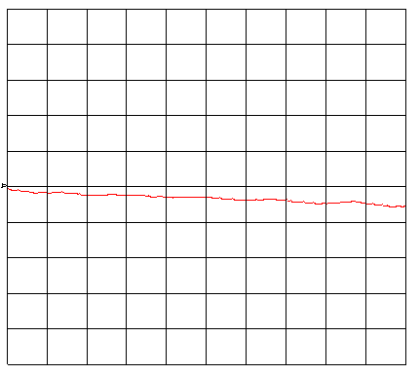

The operator should be looking for a relatively smooth downward slope. If a trace similar to that shown below is displayed, this is a sign of a bad thru connection, either the thru cable may be damaged, or more likely it is not connected properly.

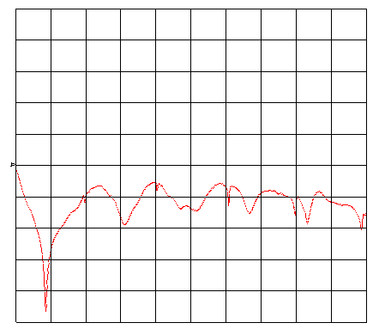

If a bad Thru cable is connected, the software will normally detect this, and prompt the user to re-test the connection. However if the cable is partially connected, the software may not always detect it, so it is important for the operator to take time when performing the calibration to ensure it is valid.

Open Calibration

The open is plotted on the analyzer as a phase plot. This should appear as a sharp saw-tooth appearance.

Short Calibration

The Short is also plotted on a phase plot. It should be noted that the short, when connected, will instantly change to show the saw-tooth display at exactly 180 degrees difference to the open plot. If either the open or the short was not correctly connected, the software will prompt the user to re-test both the open and short standards.

Load Calibration

The Load is plotted on a Log Magnitude display. This will look something similar to the plot shown below:

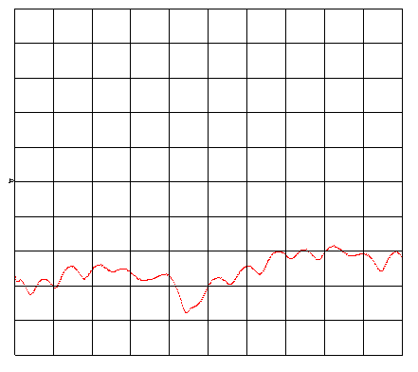

Calibration Frequency

The periodic re-calibration of the system is essential to ensure best possible accuracy. How often the system should be re-calibrated is dependent on many factors such as test frequencies, connection repeatability, physical movement of any system components and temperature and environmental variations.

Where temperature is well controlled to within +/- 3 degrees, and there are minimal environmental factors (i.e. no dust and few vibrations), calibration of the system can be performed weekly or even monthly. In a very well controlled environment, typical re-calibration periods could be 30 days or longer.

It is however important that the system manager works out the best settings for the environment of the system, as each situation is different.

Previous Calibration

During the calibration, you can press CTRL + P at any time. If a previous calibration file has been performed, this will display information about the time and date of each cal pair, and in the case of the 25-pair system, will show if the pair has never been calibrated.

Pair Information screen

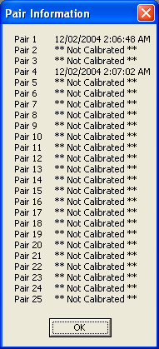

Viewing Calibration Data

The Calibration Co-efficient data can be viewed at the end of a calibration, by clicking the View Cal button, or from the main menu, by selecting System Setup, Diagnostic, View Cal-Coefficients, this allows you to view a previously performed calibration file. The actual text data will be displayed on the screen, with a graphical example of the S-parameter calibrations below.

When performing the calibration, it is good practice to get into the habit of viewing the calibration data, to check there are no problems. From the plots below, you can see a good calibration has reflection data around the calibration value 50 Ohms, and transmission data that is slowly increasing loss as the frequency increases.

Typical Balunless Cal-coefficients (Good calibration)

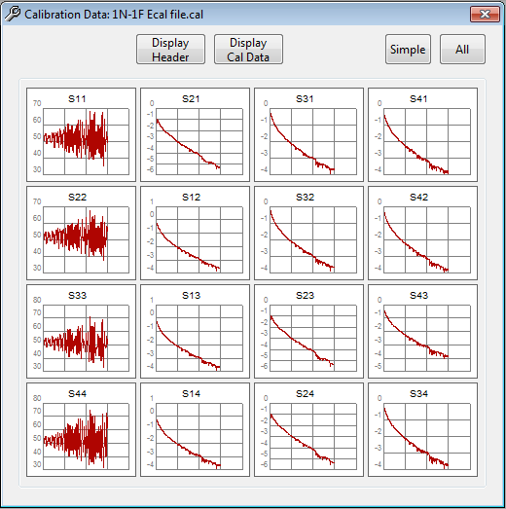

LF CALIBRATION

LF Calibration Overview

The calibration for the low frequency fixture is much less critical than for the high frequency. Once this has been performed for the first time, providing the fixture is not replaced or removed, it should keep its calibration indefinitely. Under normal operation, we would recommend re-calibrating the low frequency each time the LCR meter receives its yearly calibration or if the fixture cables are removed.

To select this option, from the main menu, select Calibrate, then Perform LF Cal.

Selecting LF Cal menu option

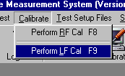

When running the Low Frequency calibration, the software will prompt for the Open and Thru connections to the fixture, as described in the following sections.

Open (Capacitance)

The near end of the Low Frequency fixture should be left open at all pairs.

Performing LF Open Cal

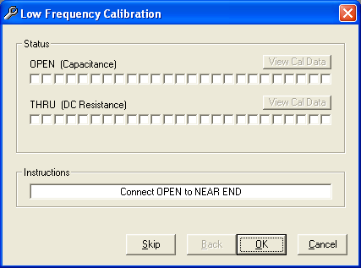

If the user presses Skip, the previous calibration will be used, and software will go onto the Thru cal. As each pair is calibrated, the boxes will be ticked. If you let the mouse linger over a box, the actual data read will be displayed. When all pairs have been calibrated, if you click the “View Cal Data” button, the data for all calibration pairs will be displayed in a separate window, this is useful for diagnostic purposes.

Thru (DC Resistance)

The software will prompt the user to connect the Thru Cable to each pair in turn to the fixture. On the 4-pair or Z2010 systems, it is also important that the pair cores match up at both ends. The thru-cable should be made from a short length of typical cable that will be tested on the system (ie: Category 5 cable will be fine).

When performing the cal, if a cable is not correctly connected, the software will display an error message, and wait for the user to correct the problem. In the event that this happens, you should check the following:

- Check the pair cores match-up at both ends
- Check the connections at both ends
- Check that the cable end is going to the correct pair on the fixture

You will be able to tell when you have a good connection, by watching the LCD display on the front of the LCR meter. When you have a good connection, the result displayed will remain fairly constant. When there is a bad connection, the result will be very eratic.

If you make a mistake during the calibration, the Back button allows you to step back to the previous pair.

Performing LF Thru Cal

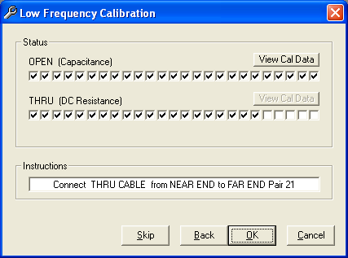

Pressing the Skip button during the calibration will skip that pair and use the results from the previous calibration, and the View Cal Data button will be available when all the pairs have been calibrated.

Viewing Calibration Data

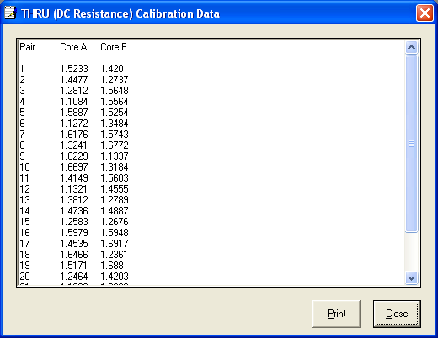

MEASUREMENT DEFINITIONS

Impedance

Impedance is the relationship between voltage and current (ratio of voltage to current) at any given point along a pair. Impedance can be measured using Termination and Open/Short. The Termination method should be suitable for most of the time, if you are having problems with ringing at the low frequencies (less that 10MHz), the Open/Short method can be used instead. The result is reported in Ohms.

Math to convert Real & Imaginary values to Ohms

Impedance = 100*(Sqr((((1+x)*(1-x)-(y^2))^2)+((y+y)^2))/(((1-x)^2)+(y^2)))

Where: x = Real
y = Imaginary

Open/Short Math

When the Open/Short method is used, two sweeps are made for Impedance, the following math is used to calculate the Impedance from these values:

Impedance Open/Short = Sqr(x * y)

Where: x = Impedance Open (Ohms)
y = Impedance Short (Ohms)

Example Impedance Test

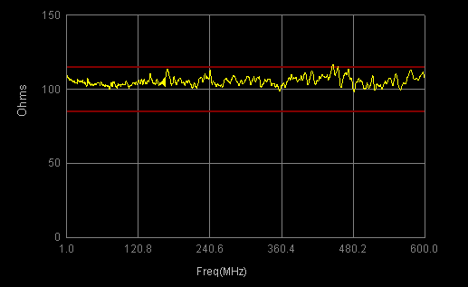

Fitted Impedance

This test uses the results from either the Open/Short or Terminated impedance at the near or far end. The results are smoothed using the “Least Square Function Fit” as defined in Section 44 of the ASTM D 4566-94. It is possible to define the curve fitting order in the Instrument Setup file (the default is a 2nd order curve fit). The math will lower the curve fit until it either reaches a zero order curve fit (ie: a flat line) or when the following conditions are met:

- The results below 3MHz must not be going up
- The value at 10MHz must be within +5 or –2 Ohms of the smoothing constant k0

For the best results, the raw Impedance data should go through 3 decades (e.g. sweep from 0.3MHz to 125MHz).

Example Fitted Impedance Test

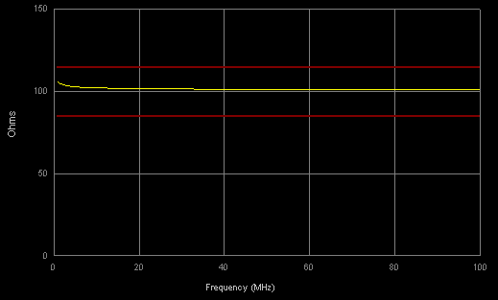

Return Loss

Return Loss is the measurement in decibels (dB) of noise or interference caused by dissimilarities in Impedance along a transmission line at various frequencies. Return Loss can be tested using either Terminated or Open/Short, and from both the near and far ends. Terminated should be fine for the majority of testing. Open/Short is provided in case of problems testing short lengths or very tight specifications. Open/Short testing will take longer, as this requires the far end of the cable to be physically opened, then shorted, but has the advantage of improving the results at the lower frequencies (below 10MHz).

The software is capable of calculating return loss in two different ways, using Standard and Complex math. Complex is the recommended method as per the standards, but the alternative Standard method can be selected if required. This feature is configured by setting the, Return Loss Calculation Method, under the System Properties, Test menu.

Complex Calculation Method

RL = 20 * Log10 ( Sqr ( (x^2) + (y^2) ))

Where: x = S11 Real (S22 for Far End)
y = S11 Imaginary (S22 for Far End)

Standard Calculation Method

RL = 20 * log10 ((x-100) / (x+100))

Where: x = Impedance (Ohms)

Example Return Loss Test

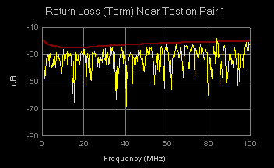

Structural Return Loss

Structural Return Loss (SRL) is a measurement of the uniformity of Impedance along the cable’s length. Low SRL values indicate changes in pair impedance or impedance non-uniformity. Factors that affect cable impedance uniformity are any change to the pair’s construction along the pair’s length, i.e. changes to conductor diameter, insulation thickness, insulation eccentricity, dielectric constant of the insulation system, and the evenness of the pair twist.

This test is calculated using the results from the Impedance and Fitted Impedance tests, and can be taken from the Terminated or Open/Short results. The structural return loss is calculated by having the load standard impedance equal to the smoothed value of the characteristic impedance at each frequency point. This is as defined in ASTM 4566-94.

SRL Math

The following math is used to calculate the SRL:

SRL = 20 * Log10((Impedance – FitImpedance) / (Impedance + FitImpedance))

Example Structural Return Loss Test

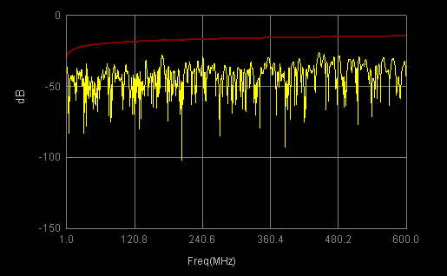

Insertion Loss

Insertion Loss is the loss of signal strength during transmission. Due to losses in the transmission medium, (such as resistance in a cable), the received signal may be lower in strength than the transmitted signal. The test results are converted from real and imaginary to dB’s, normalised to db/100m, then compensated for temperature.

Math to convert Real & Imaginary values to dB’s

Result in dB = 20 * Log10(Sqr(x ^ 2 + y ^ 2))

Where: x = Real
y = Imaginary

Length Normalisation

Normalised Insertion Loss = Insertion Loss * (100 / L)

Where: L = Cable Length in Meters

Temperature Compensation

The system will also compensate for variations in temperature using the following algorithm:

Temperature Corrected Insertion Loss = x * 1 / 1 + c * t – 20

Where: x = Normalised Insertion Loss
t = Temperature in Celsius
c = Correction factor

The default correction factor is 0.4% (0.004) for temperatures between 20C - 40C, and 0.6% (0.006) for temperatures between 40C and 60C.

User Defined Equations

Different temperature correction factors can be specified by entering the math in the User Defined Equations option in the Specification file. This is particularly useful if you are testing other standards that have different requirements for the compensation.

If you wanted to apply a correction factor of 0.4%, you would enter 0.4 in the equation box. If you wanted a more complicated setup, ie: 0.2% for temperatures 20-40, otherwise 0.4%, you would enter the following equation:

if(20 to 40 then 0.2 else 0.4)
or
if(20<= temp & temp <=40 then 0.2 else 0.4)

Example User Defined Equation

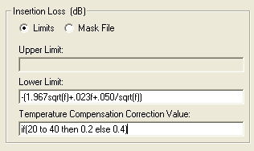

Example Insertion Loss Test

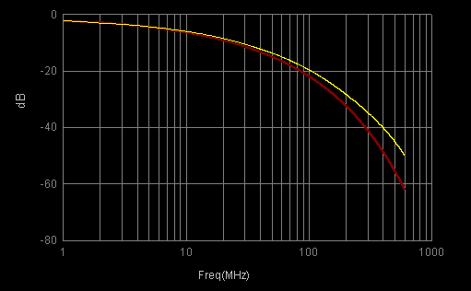

NEXT

Crosstalk is an interference caused when signal frequencies from one line are coupled onto an adjacent line. Near End Crosstalk (NEXT) is measured at either the near or far end, between all pairs. For a 4-pair cable, the following pair combinations will be measured:

Standard NEXT pair combinations

1N-2N
1N-3N
1N-4N
2N-3N
2N-4N
3N-4N

For Pair-Pair NEXT, the previous combinations will be used (i.e. 6 traces will be reported). NEXT can also be tested as Worst Case, and Powersum.

NEXT Worst Case

This is the worst case at each point for each pair, and is reported as a separate trace for each pair.

For Example, for pair 1 of a 4-pair cable:

NEXT Worst Case Pair 1 = WorstOf ( x, y, x)

Where: x = 1N-2N
y = 1N-3N
z = 1N-4N

Next Powersum

This is a calculation on each pair in a similar way to the Worst Case measurement.

For example, for pair 1 of a 4-pair cable:

NEXT Powersum Pair 1 = 10 * Log10( 10^(x/10) + 10^(y/10) + 10^(z/10) )

Where: x = 1N-2N
y = 1N-3N
z = 1N-4N

NEXT Alien Crosstalk

There is an option in the System Properties, Test menu to allow Alien Crosstalk Powersum to be calculated instead of the regular powersum calculation.

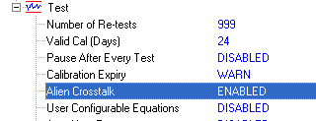

When enabled, the powersum will be calculated as two separate tests, NEXT Powersum Near End will become Pair-Pair NEXT Powersum, and NEXT Powersum Far End will become Pair-Group NEXT Powersum. Separating this test into two, allows different limits to be applied to pair-pair and pair-group.

Pair-Pair is calculated using the standard powersum algorithm, but only using the pairs within each bundle. There will be one result for each pair. Pair 25 is effectively in a group on its own, so it is considered to be included with the other pairs in the previous group. An example of the pairs to be calculated are shown below:

Pair 1: 1-2, 1-3, 1-4
Pair 2: 1-2, 2-3, 2-4
Pair 5: 5-6, 5-7, 5-8

Pair-Group calculates each pair with all other groups. For example:

Pair 1: 1-5, 1-6, 1-7, 1-8 …… 1-24, 1-25
Pair 5: 1-5, 2-5, 3-5, 4-5, 5-9, 5-10 ……. 5-24, 5-25

Example Next Test

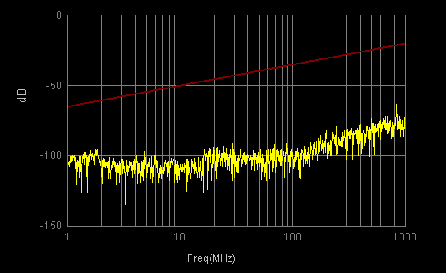

FEXT

Far End Crosstalk (FEXT) is measured from the near to the far end (or the other way round for Far End), and is measured for all pair combinations. FEXT can either be tested as Pair-Pair, or as powersum (as described for NEXT), in which case only one trace is reported for each pair. For a standard 4-pair cable, the following combinations will be tested and reported:

Standard FEXT pair combinations

1N-2F
1N-3F
1N-4F
2N-1F
2N-3F
2N-4F
3N-1F
3N-2F
3N-4F
4N-1F
4N-2F
4N-3F

Example FEXT test

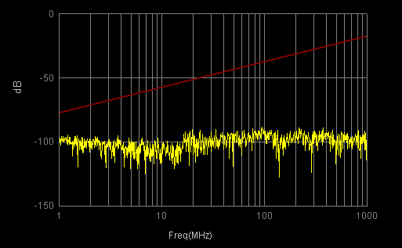

ACR

Attenuation Crosstalk Ratio (ACR) calculates the ratio of the pair attenuation (per 100m) to each pair of the NEXT results. ACR can be reported as Pair-Pair (1 result for each NEXT test), Worst Case (1 result for each pair), Powersum (1 result for each pair), Worst Case Worst (1 overall result), or Powersum Worst (1 overall result).

Powersum ACR is a good measure of how well a network will perform on a cable because it examines the two main parameters driving LAN performance, Crosstalk and attenuation. This test has become more important, as new applications and data rates increasingly require that all four pairs are being used simultaneously (full duplex transmission). Since both Attenuation and Crosstalk increase with frequency, there will be some frequency where the crosstalk signal will overcome the transmitter signal. This frequency defines the upper limit of the usable bandwidth of the system, and defines the highest frequency to which the cable will operate.

ACR Math

The calculation for ACR is shown as follows for pair 1 of a 4-pair cable:

ACR = ABS (NEXT) - ABS (Attenuation)

Example ACR Test

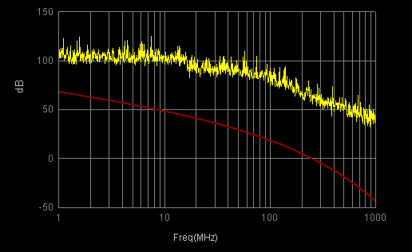

ELFEXT

Equal Level Far End Crosstalk (ELFEXT) is calculated from the FEXT and the Attenuation. For regular Pair-Pair ELFEXT, the results will be reported for every FEXT combination, so for a 4 pair cable, there will be 12 results. ELFEXT can also be reported as Worst Case, Powersum, Worst Case Worst, Powersum Worst, and from either end of the cable. The Alien Crosstalk option described in the NEXT test definition can also be applied to this test, for full details of how this affects the results, please refer to the NEXT test section.

ELFEXT Math

ELFEXT = FEXT + ABS (Attenuation)

Example ELFEXT Test

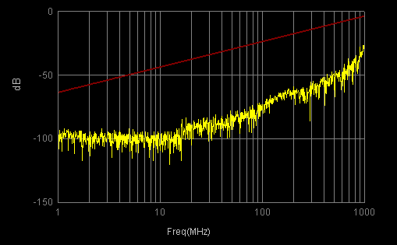

Group Delay

This test measures the delay in nanoseconds per meter for each pair using the "delay" measurement on the Network Analyzer. This calculates the change of phase with frequency as described in the operation manual for the analyzer. This test is not required for compliance with the standards, and has just been included for reference. For testing for standards compliance, the Delay test should be used instead, as it is calculated from the Phase line.

Example Group Delay Test

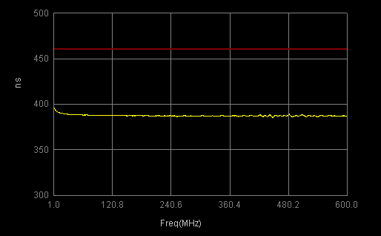

Velocity of Propagation

This test measures the phase response of the cable in the forward direction and calculates the velocity of propagation as defined in ASTM 4566-94 section 39 and 41. It is reported in percentage terms relative to the speed of light.

Velocity of Propagation Math

VOP = ((1 / ((d/100) / s)) / x) * 100

Where: d = Delay Results in ns/100m
s = 10 ^ 9 (Convert to Seconds)
x = 3 * 10 ^ 8 (Speed of Light)

Example Velocity of Propagation Test

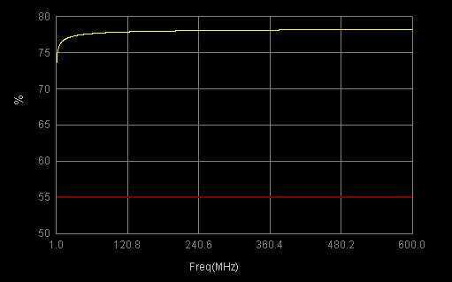

Delay

This test measures the phase response of the cable pair, and calculates the Delay as defined in ASTM 4566-94 section 39 and 41. It is scaled to be in ns/100m.

Delay Math

Delay = ((((k * 360) - p) / (360 * f)) * s) * n

Where: p = Phase value
k = number of times phase line is broken-up
f = Frequency (MHz)
s = 10 ^ 9 (Convert to Seconds)
n = 100 / CableLength

Example Delay Test

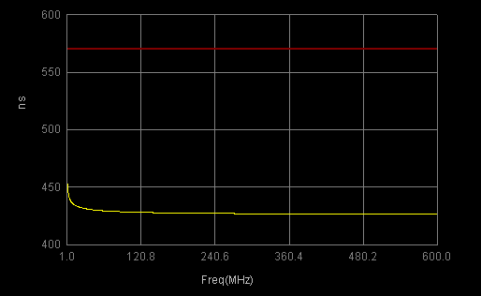

Skew

This calculates the difference between the inverse of the best Delay and the worst Delay at each frequency point.

Skew Math

Skew = Max(d) – Min(d)

Where: d = Delay Result (ns/100m)

If the cable is configured as a bundled type, Skew is calculated within its separate groups.

Example Skew Test

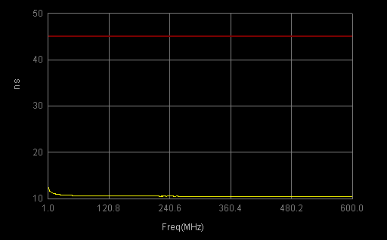

LCL

LCL, also called near-end unbalance attenuation, measures cable balance by comparing the signal appearing across the pair to the signal applied between ground and the pair, where the applied signal and the across pair signal are at the same end of the cable.

This test requires optional baluns with a common mode port. To perform the measurement, a signal is sent down the common mode port at the near end, and measured on the differential port. All other ports are terminated.

TCL

TCL is measured in exactly the same way as LCL, but the signal is sent down the differential port, and measured on the common mode port.

LCTL

LCTL is measured by injecting a signal down the common mode port at the near end of the cable, and measured at the differential port, at the far end of the cable.

TCTL

TCTL is measured in exactly the same way as LCTL, apart from the signal is injected down the differential port at the near end of the cable, and measured at the common mode port, at the far end of the cable.

ELLCTL

This test is exactly the same as LCTL, except that the Attenuation is taken out of the results.

ELLCTL Math

ELLCTL = LCTL – Attenuation

ELTCTL

This test is exactly the same as TCTL, except that the Attenuation is taken out of the results.

ELTCTL Math

ELTCTL = TCTL – Attenuation

Attenuation Deviation

Attenuation Deviation is not currently a test requirement, but has been included for future use. It reports one trace for the whole cable, and measures the difference between the best and worst cable pair at each point.

Attenuation Deviation Math

Attenuation Deviation = Max (a) – Min (a)

Where: a = Attenuation db/100M

Surface Transfer Impedance

Surface Transfer Impedance is a special test performed on a 1 Meter length of cable. It requires special connection using an optional test fixture. The results are returned as Milliohms.

Surface Transfer Math

Transfer Impedance = 100 * sqr(10^(-Abs(x)/10)) * 1000

Where: x = S12 converted to dB’s

DC Resistance

DC Resistance is measured on the low frequency fixture. For each pair there are two results, one for each core. Typically, the larger the gauge (AWG) size of the cable, the lower the resistance. The results are shown normalized to Ohms/100 Meters.

Normalization

The results are normalized to using the following algorithm:

Normalized_DCR = (DCR * (1 / Cable_Length)) * Normization_Length

Temperature Compensation

If a temperature value is entered at the start of testing, or an automatic temperature detection fixture is being used, the following algorithm will be used to compensate:

Temperature Corrected DCR = x * 1 / 1 + 0.00393 * t – 20

Where: x = Normalised DC Resistance
t = Current temperature in Celsius

DC Resistance Unbalanced

DC Resistance Unbalanced is calculated from the two DC Resistance results for each pair. It is reported as a percentage difference between the pairs. The system is setup to test using the ASTM method by default, however other methods can be specified, please set the specification file section of the manual for details how to do this.

DCR Unbalance Math (ASTM 15.3) (Default)

DCR Unbalance = 100 * (a - b / Max(a,b))

Where: a = DC Resistance Core A (Ohms/100M)
b = DC Resistance Core B (Ohms/100M)

If you need to test to the ISO method, the specification file needs to be configured with the equation shown below.

DCR Unbalance Math (IEC-61156-1)

DCR Unbalance = 100 * ((Max(a,b) – Min(a,b)) / (a + b))

Where: a = DC Resistance Core A (Ohms/100M)
b = DC Resistance Core B (Ohms/100M)

User Defined Equations

The IEC test method can be configured by entering the following equation:
100(abs(a-b)/(a+b))
For all other equations the following variables can be used:
a : DC Resistance Core A (Ohms/100M)
b : DC Resistance Core B (Ohms/100M)

DC Resistance Unbalanced (Pair-Pair)

DC Resistance Unbalanced Pair-Pair tests the difference in conductors between pairs, and is reported as a percentage. All pair combinations are tested (6 results for a 4 pair cable).

The default method of testing uses IEC-61156-1:

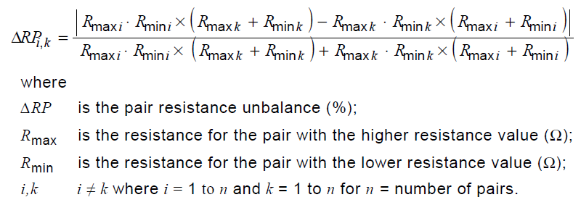

It is also possible to configure the TIA method:
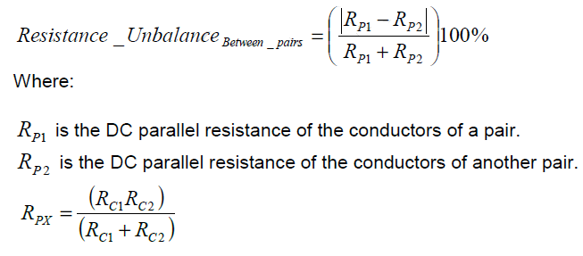 This can be used entering the following equation in the Test Calculation box:

100((abs(((a*b)/(a+b))-((c*d)/(c+d))))/(((a*b)/(a+b))+((c*d)/(c+d))))

Capacitance Unbalance (Pair-Ground)

Capacitance Unbalanced Pair-Ground is a measurement of each core in turn to every other core and the ground. This measurement requires a manual open circuit of the cable at the far end on the 4-pair systems. The result is reported in pF/100meters.
Capacitance Unbalance (Pair-Ground) Math

CUB = ABS( a – b ) * n

Where: a = Core A to all other pairs & ground
b = Core B to all other pairs & ground
n = 100 / CableLength (Normalise to 100 Meters)

User Defined Equations

This test can also be configured to give both a negative or positive result by removing the ABS command, by entering the following equation:
a–b
Please note, the final result will still be normalized.

Capacitance Unbalance (Pair-Pair)

Capacitance Unbalance Pair-Pair is measured on every combination at the near end of the cable (1N-2N, 1N-3N, 1N-4N, 2N-3N, 2N-4N, 3N-4N).

The capacitances CAC, CAD, CCG and CBD are the direct capacitances between conductors and are used to calculate the Pair-Pair unbalance in the following equation.

Capacitance Unbalance (Pair-Pair) Math

CUPP = ( (CAD + CBC) – (CAC + CDB) ) / n

Where: n = Sqrt ( CableLength / 100 )
CAD = Capacitance between Pair X Core A and Pair Y Core B
CAC = Capacitance between Pair X Core A and Pair Y Core A
CBC = Capacitance between Pair X Core B and Pair Y Core A
CBD = Capacitance between Pair X Core B and Pair Y Core B

Mutual Capacitance

The Capacitance refers to a cable’s unique ability to store an electric charge and to resist sudden changes in the magnitude of that charge (voltage). It is found not only between the two wires of a twisted pair, but also between two adjacent conductors in the same cable. Mutual Capacitance is measured on the cable between the two pair cores. On the 4-pair systems, this requires a manual open circuit at the far end, however this is handled automatically on the 25 pair systems. The result is reported in ns/100meters.

DC Resistance Unbalance Pair to Pair

This test is calculated from the DC Resitance results as follows: (as per IEC-61156-1)

ABS((max_i*min_i)*(max_k+min_k))-((max_k*min_k)*(max_i+min_i)))
RUPP = ------------------------------------------------------------------------------------------ *100
((max_i*min_i)*(max_k+min_k)) + ((max_k * min_k) * (max_i + min_i))

Where:
i-k = 1-2, 1-3, 1-4, 2-3, 2-4, 3-4 (DCR results for a 4-pair cable)

Mutual Conductance

The mutual conductance of a pair in a wire or cable is proportional to the mutual capacitance, the average value of the dissipation factor of the insulating system, and the frequency. For best results, measurements should be taken at short lengths, 32 foot lengths are best. The result is reported in microsiemens per 100 meters.

Manual Switch Configuration

The ‘Manual Switch Configuration’ screen, can be selected from the main menu by clicking on ‘System Setup’, ‘Diagnostic’, ‘Manual Switch Configuration’.

The options available from this screen are described below.

RF Switching

This screen allows any path combination to be setup between the RF fixture and the Analyzer. Clicking on any of the switch buttins will switch in that path to the network analyzer. A connection to Port 1 is shown in blue, and Port 2 is shown in red. Right-clicking on a button allows alternative options to be selected for that path, such as Common Mode switching or open/short connections.

RF Switching Screen (4-Pair fixture)

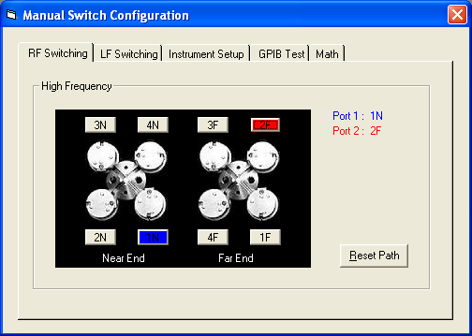

RF Switching Screen (25-Pair fixture)
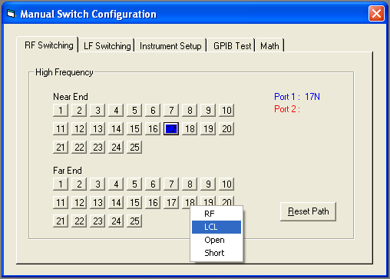

This screen is very useful for diagnosing switch or cabling problems with the system. For example, if there was a problem with measurements on 2N, you could use this screen to switch in 2N to Port 1 or Port 2 of the analyzer, and verify on the analyzer if a signal is getting through correctly.

LF Switching

The LF switching setup screen allows all of the LF paths to be manually switched in as required. The LF switch type is selected on the left of the screen, and the pair number is shown on the right.

This screen is useful for diagnosing problems on the Low Frequency unit. For example, if you were getting strange readings on Pair 9 Core A resistance unbalance, you could switch that pair in, and first check that the open circuit reading matched that given on the other pairs, then connect a thru cable in check that gave a similar result to the other pairs. This will prove if there really is a hardware fault or simply an incorrect calibration.

LF Switching Screen

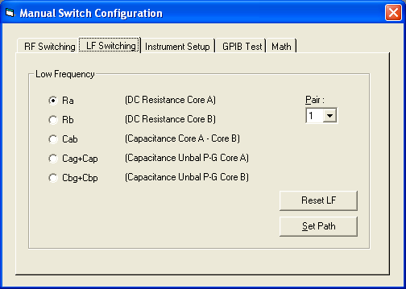

Instrument Setup

The ‘Instrument Setup’ option allows the network analyzer or LCR meter to be configured for specific measurement states. This screen would primarily be used by operators who need to diagnose problems, but are unfamiliar with the operation of the Agilent instruments. For example, if there was a problem with DC Resistance measurements, and we were going to use the Switching Setup screen to check some DC Paths, we could first setup the LCR meter for reading DC by selecting ‘DC Resistance’, and then pressing ‘Setup’ in the LCR Mode box.

Manual Instrument Setup

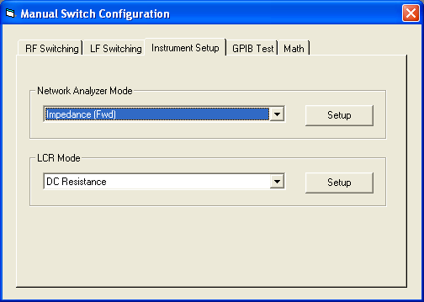

GPIB Test

The GPIB Test screen would primarily by used by support technicians for development work on the instruments. It allows raw commands to be sent to any of the GPIB instruments connected to the system. In normal use, this screen will not be required for diagnostics unless directed by a support technician.

GPIB Test Screen

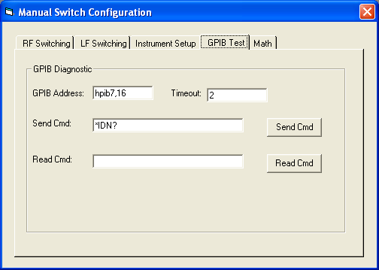

Math

The Math screen allows math algorithms to be entered and quickly evaluated. This is useful for checking changes to the standards or evaluating other equations without having to create a new specification file.

Math Screen

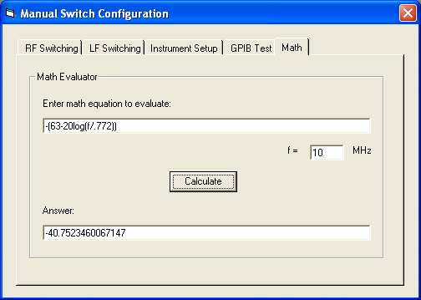

DIAGNOSTICS

Diagnostics Overview

A number of facilities have been included with the system to diagnose potential problems. Before calling for support, it is recommended that these procedures are run to determine the cause and possible solution to any problems.

Selecting the Fault Finding menu option

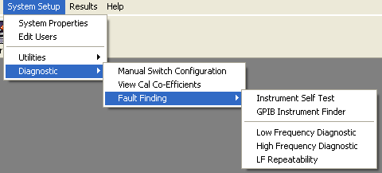

Instrument Self-Test

From the main menu, select System Setup, Diagnostic, Fault Finding, Instrument Self-Test. This will perform a check on the GPIB card and every instrument setup in the system properties, and will alert you to any potential configuration issues.

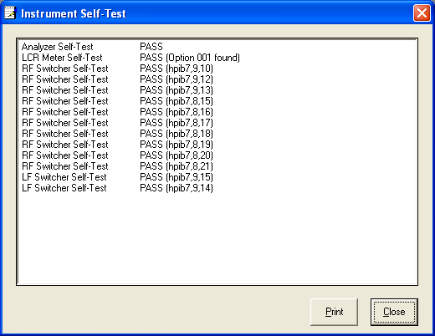

Bad Switch List

If after diagnosing the system, a bad switch is identified, a temporary measure can be used to allow those switch paths to be overridden. To do this, create a new text file in the CableTest directory called BadSwitchList.txt

Inside this text file, enter any bad switch paths on a new line, for example:

3N-2
4F-1

In this example, the switch connecting 3N to Analyzer Port 2, and the switch connecting 4F to analyzer Port 1 would both be diverted to use other paths.

This feature is not fool-proof, and should only ever be used as a temporary measure to get around switching problems, while you wait for hardware maintenance on the system.

Instrument Driver Setup

The cable test software has a GPIB library to control all of the instruments connected to the system. In order for the test system to operate correctly this high level driver must be operating correctly. If there is a problem with the system not being able to talk to any instruments or timing out on the GPIB bus, then there may be a problem with the card or driver.

To select the driver setup utilities, there should be a blue IO logo displayed in the Windows 98/NT system tray (as shown below). There is one option, which is of particular use for diagnosing GPIB problems, Run I/O Config.

IO icon in the system tray

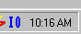

Selecting Run I/O Config

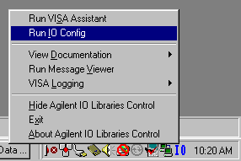

Run I/O Config

Selecting this option will bring-up the screen shown below. The GPIB card is shown as hpib7. Further diagnostics can be run by clicking on the hpib7 card and pressing ‘Edit…’

Selecting IO Libraries Configuration

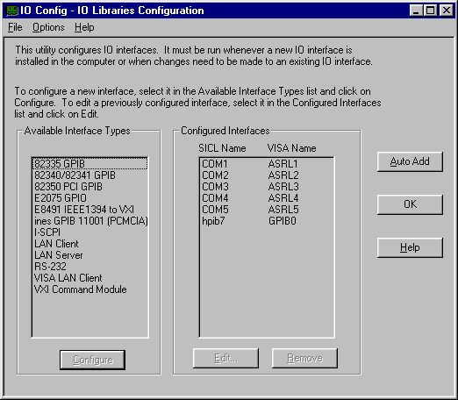

Pressing ‘Edit…’ will display a setup screen, all the default values should be ok for normal use. From this screen press ‘Edit VISA Config’. This will bing-up the following screen.
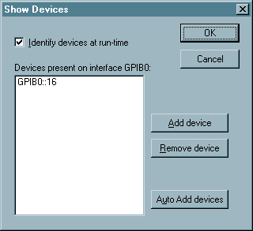

If there are already devices listed in the white box (as shown on the example above) then complete the following procedure:

The devices listed on the screen will be stored from the last time this program was run. Click on each item in turn, then Remove device. When all devices have been removed, press OK, then OK again, then OK again to leave the program. Then re-run the I/O configuration software and return to this screen in the same way as described above.

Press Auto Add devices, this will force the GPIB card to search for devices attached to the system. If it is working correctly a list of devices will be shown. If there are any problems with the card or the driver then an error message may be shown. In the event of an error, it may be that the system just needs re-booting. If this happens perform a full shutdown of the system and the instruments and try the above procedure again. If an error is still returned then there may be a problem with the GPIB card.

Trouble Shooting

In the unlikely event of a system problem, before calling for support, the following tests should be made to find the cause of any problems:

Software Installation Problems

- When I install the cable test software, I get the error message shown below:

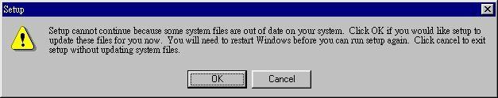

This is not a problem; it is just because you are using an older version of Windows that needs further updating. Just allow the system to re-boot, and run the setup problem again.

- I am still getting the same error message as the previous problem, even when I have restarted the system.

This error sometimes occurs in some revisions of Windows when particular drivers do not exist. To correct the problem, there is a sub-directory, under the \CableTest\ directory on the CD called \CableTest\PreInstall\. You should run the setup.exe program from this directory, allow the system to re-boot, then run the main setup program. It should work fine from now on.

Software/PC Problems

- I can’t login to the cable test software.

Have you deleted the user file? Check that the following file exists ‘C:\Windows\HPTest Users.Usr’ If this file is erased a default file will be created, you can use the user name ‘HP’ and the password ‘HP’ to logon to the system and re-create all the entires.
Have you erased all entries in the user file? If this happens, delete the file ‘C:\Windows\HPTest Users.Usr’. When you login the next time, a default file will be created and you can login with the user name ‘HP’ and password ‘HP’.

- All the system property settings have been reset back to their default values.

Have you deleted the System Properties file ‘C:\Windows\HPTest Config.Mdb’? If the software does not find this file, it will create a new default file with all default values set for the properties. You need to set all the properties with the relevant settings.

- I have deleted all of the files on my Hard Disk or my Hard Disk has failed.

Every HP PC comes with a recovery CD for installing Windows. You need to install this, then install the cable test software and drivers off the Cable Test Installation CD. The instructions for doing this are contained in section 1 of this manual, and also on the CD. In order to prevent this from being a major problem, we recommend that you back-up the complete test system at least once a week. Please note, hard disk drives are mechanical devices containing moving parts and they will eventually fail, therefore it is essential that you back-up your test system regularly.

- I have accidentally deleted various files from my Windows or WinNT directory.

Many of the files contained in the Window directory are needed to run the test system. You will need to re-install everything as described in the previous answer.

- All the menus and on-screen text is in displayed as funny squiggles or in another language.

You have changed the language setup in the system properties. From the main menu, select the fifth from left drop down menu, followed by the top menu item. Within the system properties, now select ‘System’, ‘Language’ and change this back to your native language.

Testing/Setup Problems

- At the start of the test, a screen is shown which says ‘Product file (filename shown) is empty. At least one product entry must be specified’

You have selected to test a product file with no entries in it. Go to the main menu, select Test Setup Files, Product, and then select the product file you just tried to run. You must setup at least one cable product before you can test anything.

- At the start of the test, a screen is shown which says my calibration does not exist.

With every new instrument setup file that is specified, a new calibration must be performed. From the main menu, click on the Calibrate button, and select the instrument setup file to calibrate, and perform a full calibration prior to testing.

- At the start of the test, a screen is shown which says my calibration is invalid.

Every time a change is made to the instrument setup file, the associated calibration becomes invalid. You must re-do the calibration for this file.

- At the start of the test, a screen is shown which says my calibration has expired.

This means that the calibration expiry period specified in the system properties has been reached. You must either increase this value if you wish for the calibration to remain valid, or re-do the current calibration.

- At the start of the test, a message is displayed telling me that I do not have continuity.

The cable is not hooked up correctly to the fixture. Please check the connections and re-test. You will know when you have a good connection, as the message on the analyzer screen will change from a FAIL message to PASS.

- The results for one or more pairs do not look anything like they should.

Either the cable is not hooked up correctly, or the calibration is invalid. You should first check that the cable is connected correctly. If it is, then it means that the calibration is invalid. You can re-do one pair in a calibration file by selecting ‘Part Cal’ at the start of the calibration process, and choosing which pair you want to re-cal.

- The test results look strange (i.e. not what I expect)

After testing the cable, swap the ends over (i.e. connect the near end of the cable to the far end of the fixture, and the far end of the cable to the near end of the fixture). Then re-test the cable from the far end of the fixture. The results should follow the cable, and not stay with the pair, for example, if there is an unusual spike and it follows the cable then that probably is a characteristic of that particular cable.

- The Delay or VOP results look very strange (i.e. not what I would expect)

The Delay and VOP tests are calculated from the Phase. The length of the cable is very critical to the calculation, for example, if a length of 100 Meters was specified at the start of the test, and 200 Meters of cable was connected to the fixture, the results would look wildly incorrect. It is also important that the Analyzer is setup with enough resolution to ensure that there will be a point on every phase shift. As a rough calculation:
X = ((Stop_freq - Start_freq) / Points) * (CableLength / 100)
If X > 2 then there will not normally be enough resolution to correctly calculate Delay. In order to increase resolution, you should increase the number of points, test over a reduced frequency range, or test a shorter length of cable.

- I am not sure if I should be testing Delay or Group Delay.

Delay is essentially the same as Group Delay, however it is calculated as per the standards. Group Delay is not required by the standards and has just been provided as an additional test to provide extra functionality in the test system.

- The reports do not load up automatically at the end of a test.

If the test was aborted, the results do not load by default. To enable the results loading when this has happened, click the box titled ‘Produce Reports’ at the end of the test. If you did not abort from the test, check that the file specified in the system properties exists on the hard drive. The default name for this file is: ‘C:\CableTest\Reports\Report.exe’.

HPIB Card Problems

- Software is not communicating with the GPIB card.

Re-boot the PC and turn all instruments off then on again and try again.

- The software is still not communicating with the GPIB card.

From the main menu, select ‘System Setup’, ‘Diagnostic’, ‘Fault Finding’, ‘Check GPIB Card’. This will check the communication between the system and the installed GPIB card. If this works ok then the problem is probably with an instrument connected to the system with an invalid address etc. If the ‘Check GPIB Card’ test fails then the problem is most likely to be a faulty GPIB card or missing/incorrectly setup driver software. For information on setting this up refer to section x.x of this manual, and the accompanying documentation provided with the GPIB card and driver software.

- The software is not communicating with one of the instruments.

From the main menu select, ‘System Setup’, ‘Diagnostic’, ‘Instrument Self-Test’. This will perform a basic self-test on every instrument connected to the system. If any of the instruments fails the self test, it will be for one of the following reasons:
- The instrument of not connected to the GPIB – Check the GPIB cable is securely connected at both ends, or possibly replace the cable.
- The instrument is not switched on.
- The GPIB number specified in the System Properties is different to that specified by the analyzer.
- The instument type specified in the System Properties is different to the actual instrument connected, (for example: HP8751 is specified instead of HP8753).
- The instrument is not connected to the system at all (for example a system without LF will not have a HP4263 connected). If an instrument is not connected, the System Properties should be set to 0.

Analyzer Problems

- There is no power going to the analyzer.

Is the power cable connected at the back of the analyzer? Is the voltage switch set to the correct position? Most US, Asian and European systems operate at 110Volts, UK systems operate at 240Volts. Check the power cable is ok, by using a cable from another (correctly working) instrument.

- The software is not communicating with the analyzer at all.

Please check the following things:
- On the analyzer press “Local”, and check that it is set to “Talker/Listener” mode on the softkey.
- Check that the Analyzer GPIB code set in the system properties, is the same as that set on the analyzer. On the analyzer, press “Local”, “Set Addresses”, “8753”. This should be set to the same as the following setting in the system properties:

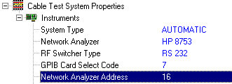

- Check that the cable is securely connected between the PC and analyzer.
- Try replacing the cable between the PC and analyzer with a known working one.

- The analyzer is returning intermittent time-out errors.

This will most likely be caused by a bad GPIB cable, replace the cable with a known good one.

- The analyzer is not working correctly for transmission tests.

Check that you do not have Take4 mode set to True in the Instrument Setup file, this feature only works for some early 8753E model analyzers. If this is not the problem, you can check the hardware by doing the following procedure: disconnect the fixture from the analyzer. Connect a thru cable (supplied with the analyzer) from the near end to the far end of the analyzer. Then select to view a forward attenuation measurement on the screen. Then change the display to a reverse attenuation measurement. The results for these two measurements should be almost identical. If they are not, then there is a problem with the analyzer.

LCR Meter Problems

- There is no power going to the LCR Meter.

Is the power cable connected at the back of the meter? Is the voltage switch set to the correct position? US and Asian and European systems operate at 110Volts, UK system operate at 240Volts. Check the power cable is ok, by using a cable from another (correctly working) instrument.

- The software is not communicating with the LCR Meter at all.

Please check the following things:
- Check that the cable is securely connected between the PC and LCR.
- Try replacing the cable between the PC and LCR with a known working one.
- Check that the LCR GPIB code set in the system properties, is the same as that set on the LCR. On the LCR, press “Local”, “Blue Button”, “Local” to find out what the GPIB address is set to. This should be set to the same value as shown in the system properties.

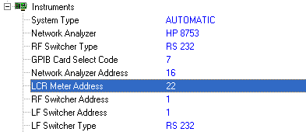

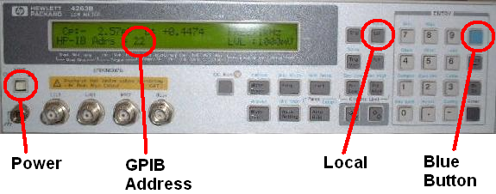

RF Switching & Cabling Problems

- The system is not switching in a particular path.

From the main menu select the following, ‘System Setup’, ‘Diagnostic’, ‘Fault Finding’, ‘High Frequency Diagnostic’. The software will then prompt you to connect a cable at every single combination on the fixture, you will need a short length of cable for this (approx ¼ meter). At the end of the check, a summary of every combination will be displayed which can be printed out. If everything passed then the switching is ok, otherwise you have a switch or cabling problem with the system.

- I have an RS232 switching fixture, and it does not seem to be working at all.

Power-down the whole system for 10 seconds, then re-start and try again.

Check that the switch unit is connected to the black power supply unit, and that this is plugged into the rack power.

Check that you have the switch unit configured correctly in the system properties. Under the instrument section, the ‘RF Switcher Type’ and ‘LF Switcher Type’ should both be set to RS232. The ‘RF Switcher Address’ and ‘LF Switcher Address’ should both be set to 1 (for Com Port 1 on the PC).

Next, check that the RS232 port is correctly configured in the Agilent I/O software. Click on the Blue IO logo in the bottom right hand corner of the PC screen and select ‘Run I/O Config’. Click on COM1 and select ‘Edit’. This screen should be configured as shown below.

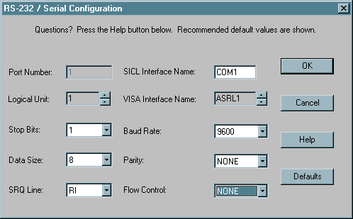

Finally, you can check that the device is working correctly using the following method. Firstly, power-off the whole system for at least ten seconds. Then when re-starting, don’t load the cable test software. Instead, load the Windows ‘Hyper Terminal’ software, configure a new session using Com1, speed 9600, data-bits 8, Parity None, Stop Bits 1, Flow Control None. You can check that the system is communicating with the switcher unit by typing ‘O’ followed by Enter. If the switcher is working ok it will respond with an acknowledge message. Also pressing ‘T’ followed by Enter should return the current temperature.

LF Problems

- The results for the LF DC Resistance tests are not giving correct results.

The LF unit may need re-calibrating. Select ‘Calibrate’, ‘LF Cal’ from the main menu.

- The system is not switching in a particular path.

From the main menu select the following, ‘System Setup’, ‘Diagnostic’, ‘Fault Finding’, ‘Low Frequency Diagnostic’. The software will then prompt you to perform a series of operations on the LF fixture; you will need a continuity tester for this. If all the tests are performed ok, then the switching and cabling is ok, otherwise there may be a problem with either the cabling or a switcher.

If you think there may be a problem, first take the back of the LF fixture (if applicable) and check that all the small blue connectors are firmly in place. These can sometimes become dislodged during transit. If this does not rectify the problem, contact HP to obtain a replacement LF fixture.

Balun Problems

- I think there may be a problem with one of my 1GHz Baluns.

Select the following option from the main menu, ‘System Setup’, ‘Diagnostic’, ‘Manual Switch Configuration’. This screen allows any path to be switched in to the analyzer by clicking on the pair buttons. To check the baluns, switch in the relevant path to port 1 on the analyzer, set the analyzer to display S11 Return Loss, the values between 1MHz and 1GHz should be better than 20dB. If they are not then you have a problem with the balun, you should replace it with the spare supplied with the system.

- I think there may be a problem with one of my 350MHz Baluns.

Select the following option from the main menu, ‘System Setup’, ‘Diagnostic’, ‘Manual Switch Configuration’. This screen allows any path to be switched in to the analyzer by clicking on the pair buttons. To check the baluns, switch in the relevant path to port 1 on the analyzer, set the analyzer to display S11 Return Loss, the values between 1MHz and 350MHz should be better than 20dB. If they are not then you have a problem with the balun, you should replace it with the spare supplied with the system.

CUSTOM REPORTS

Report Overview

The test software is supplied with a custom report package. This section describes how to setup, configure and use the built in reports. If you prefer to use your own application to generate the reports this is also supported, but you may not get the same flexibility as from using ours. A default configuration file is supplied with the system, which allows all tests to be reported in a standard format that will be suitable for most uses. This section of the manual only needs to be used by advanced users who wish to modify this original setup.

System Property Reporting Options

Under the System Properties menu option there are a number of selections, which allow an external application to be used with the Cable Test software. Select these from the Applications menu.

System Properties Applications menu

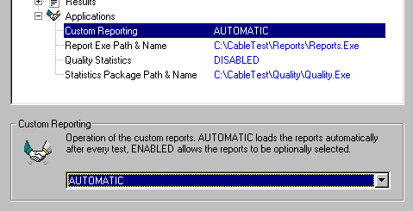

Custom Reporting

This option has three settings; Disabled will stop any running of the external reports after testing. Enabled allows the reports to be loaded, but only if the option is explicitly selected, and Automatic where the reporting package will always be loaded up.

Report Exe Path & Name

This option should be set to the full path and filename of the application to run. If you are using the built-in report package, you would select this. The default location for this is C:\CableTest\Reports\Reports.exe. If you are using your own reporting package, or some other application (such as Excel or Access) you would put the filename of the macro to load here.

Running Reports

The report package can be run from several places in the software. At the end of a test, there will be a check box in the bottom right hand corner of the screen (see screen shot below) entitled Product Reports. When this is ticked, as soon as Close is clicked, the current result file will be loaded into the report package.

End of test Report option

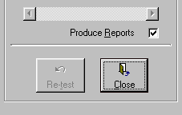

Alternatively, you can select Start Reports from either the Last Test, or Old Test menu options, which allows the reports to be loaded from the main menu.

Selecting the Start Reports option

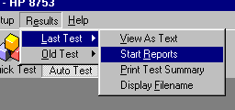

When the reports start, the main report screen will be displayed. Tick each report required in the printout, and then either press the Print, or Save As PDF button to output the data in your chosen format.

Example main report screen

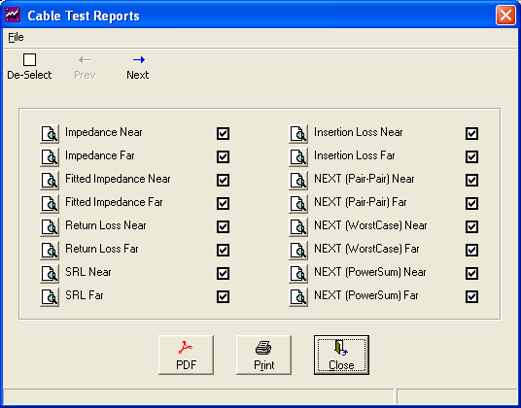

When the printout starts, the report software will be minimized to the system tray. Clicking on the icon allows the printout to be cancelled, or the main screen to be called up again.

Example minimized report icon
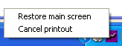

Configuring Reports

The Reporting package is called automatically from the main Cable Test Program. If it is required to call the program separately, it must be called with the results file to report as the command line argument:

C:\CableTest\Reports\Reports.exe [Full Result Filename]

In addition the file Reports.ini (described below) must be present in the same directory as Reports.exe

If a Reports.ini file does not exist, the software will prompt the user to select an alternative .ini file. This can be useful if a number of different .ini files are being used.

The user interface to the Report software is very easy to use. For each report defined there is a choice to view the report on the screen (preview) or to add it to a print job (check the tick box next to the report name).

Profiles

Profiles can be stored which allow combinations of reports to be easily selected.

To use this facility, from the main report screen select the reports you would like stored as a profile, then from the drop-down menu, select Profiles followed by Add new profile... as shown in the following screen shot:

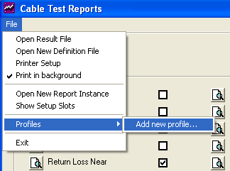

The user is then prompted to enter a name for the profile:

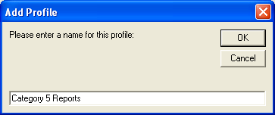

The profile will then be stored in the profile list for future use:

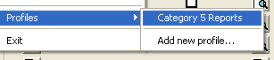

Profiles can also be setup manually as described in the [GENERAL] section below, but this automatic procedure makes the process a little easier for the user.

Also, using the AutoProfile command, a selected profile can be configured to automatically select its options on start-up depending on some criteria in the result file. This feature is described in the [GENERAL] definition section of the manual below.

Results File

The results file is described in detail elsewhere, but a brief description is given here to help explain how data is selected for a given report.
The results file consists of a number of header lines that follow the format of
KEYWORD<TAB>DATA.
Following this are a number of data blocks that represent each of the tests carried out on the cable.
Each Data Block is referred to by its test name (e.g. “Attenuation”). Data is arranged within the block on a spot frequency per line basis, Data for the tests occupy columns 2 onwards. The last three columns contain limits & pass/fail flags.
Example:
0 | 1 | 2 | 3 | 4 | 5 | 6 | 7 | 8
Point | Freq | Pair 1 | Pair 2 | Pair 3 | Pair 4 | Lo Lim | Hi Lim | Pass/Fail
1 | 1.0000 | 105.12E+00 | 103.30E+00 | 100.84E+00 | 102.35E+00 | 850.00E-01 | 115.00E+00 | PPPP
2 | 1.2475 | 102.60E+00 | 102.22E+00 | 102.43E+00 | 102.53E+00 | 850.00E-01 | 115.00E+00 | PPPP
3 | 1.4950 | 101.44E+00 | 101.55E+00 | 102.79E+00 | 102.45E+00 | 850.00E-01 | 115.00E+00 | PPPP
… | … | … | … | … | … | … | … | …

N.B. The number of columns (and hence column numbers of low limit, high limit & P/F) will vary according to the number of wires in the cable and the test performed. E.g. NEXT on a 4 pair cable will have 10 columns:
0 | 1 | 2 | 3 | 4 | 5 | 6 | 7 | 8 | 9 | 10
Point | Freq | Pair 1 | Pair 1 | Pair 1 | Pair 2 | Pair 2 | Pair 3 | Lo Lim | Hi Lim | Pass/Fail
 |  | To | To | To | To | To | To
 |  | Pair 2 | Pair 3 | Pair 4 | Pair 3 | Pair 4 | Pair 4
1 | 1.0000 | -744.25E-01 | -849.04E-01 | -781.73E-01 | -795.27E-01 | -829.37E-01 | -839.47E-01 | -100.00E+00 | -640.00E-01 | PPPPPP
2 | 1.2475 | -754.85E-01 | -810.06E-01 | -772.92E-01 | -813.72E-01 | -823.21E-01 | -899.30E-01 | -100.00E+00 | -639.20E-01 | PPPPPP
3 | 1.4950 | -803.93E-01 | -765.57E-01 | -788.93E-01 | -834.58E-01 | -820.39E-01 | -825.93E-01 | -100.00E+00 | -638.40E-01 | PPPPPP
-

Creating Bespoke Reports

Any number of different reports can be created. A report can be produced to any printer, on any paper size and orientation. However, the results will look best if printed to A4 or Legal Paper Sizes in Portrait mode. A Report consists of two parts:

- Header (top of the page)
Which consists of a Logo, A Report Title and a number of fields drawn from the results file.

These items are configured in the Report Initialisation File (Reports.ini)
The header Section will follow the same format for every report defined.

- Data Results (rest of the page)
The Data part of the report consists of a number of graphs and tables. The Graphs and Tables to be displayed are configured in the Report Initialisation File (Reports.ini).

The Data part of the report is defined in terms of a hidden grid. The size of the grid in both the X and Y directions is set in the [REPORT] section. The hidden grid determines the size and location of the graphs and tables that are placed on this part of the page.

The following diagram shows the co-ordinate system for a 2 by 3 grid (X=2, Y=3). It also shows the position of a graph or table placed at location 3 (Slot=3).

Slot 1 | Slot 2
Slot 3 | Slot 4
Slot 5 | Slot 6

Report Definition File

The Report Definition File contains all the user configurable parameters that control the layout of the Reports. The file is an ASCII text file that follows the format of a standard windows initialisation file. This file is called Reports.ini and is located with Reports.exe

The file is divided into Sections. Each Section can contain a number of Keys followed by their corresponding Value. E.g.

[SECTION]
key=value
key=value

[SECTION]
key=value

A Description of each of the sections in the Report Initialisation File is given here together with an example file. This should give enough information to allow creation of further custom reports.

[GENERAL] Section

This section defines general information about the reports, and their physical appearance. Each command is described in detail below.

Logo = <Path and Filename>
The full path to the graphic file that will be printed at the top of all reports (e.g. C:\CableTest\Reports\logo.bmp). This can be any of the following formats: bmp, gif, jpg. You can also specify the filename with just a backslash before it (e.g. \logo.bmp), this means the file will be taken from the same directory as the report software.

LogoHeight = <Height in mm>
The height of the displayed logo graphic in mm. (eg: LogoHeight=15 would set the logo to 15mm). If you enter a value of -1 for this, it will use the original logo size with no scaling.

LogoCenter = <True | False>
When set to false, the logo will be printed out to the left-hand side of the page. The default is True (ie: logo will be centered in the middle).

TableFormat = <Number Format>
Specifies how to format any numbers displayed in tables.
For example, for the number 12.343434:
“0.00” 12.34
“0.0e00” 1.2e01

GridColor = <Colour>
Defines the colour of the grid on all printed graphs. This can be any color from the following list: Black, Blue, Green, Cyan, Red, Magenta, Yellow, White, Gray, LtGray, Orange, Brown. The default is Blue. Alternatively, you can enter an RGB color value using the standard RGB numbers, eg: GridColor = 200,200,0.

TableColor = <Color>
Defines the color of the tables and table heading text. This can be any color from the following list: Black, Blue, Green, Cyan, Red, Magenta, Yellow, White, Gray, LtGray, Orange, Brown. The default is Blue. Alternatively, you can enter an RGB color value using the standard RGB numbers, eg: TableColor = 200,200,0.

HeaderTextColor = <Color>
Defines the color of the tables header text and the overall header text. This can be any color from the following list: Black, Blue, Green, Cyan, Red, Magenta, Yellow, White, Gray, LtGray, Orange, Brown. The default is Blue. Alternatively, you can enter an RGB color value using the standard RGB numbers, eg: HeaderTextColor = 200,200,0.

SubHeaderColor = <Color>
Defines the color of the sub-header on a table ie: the first row after the main title bar. This can be any color from the following list: Black, Blue, Green, Cyan, Red, Magenta, Yellow, White, Gray, LtGray, Orange, Brown. The default is Blue. Alternatively, you can enter an RGB color value using the standard RGB numbers, eg: SubHeaderColor = 200,200,0.

SubHeaderTextColor = <Color>
Defines the color of the sub-header text on a table ie: the first row after the main title bar. This can be any color from the following list: Black, Blue, Green, Cyan, Red, Magenta, Yellow, White, Gray, LtGray, Orange, Brown. The default is the same as the TableColor specified above. Alternatively, you can enter an RGB color value using the standard RGB numbers, eg: SubHeaderTextColor = 200,200,0.

GraphLineThickness = <Integer>
The default for this is 0. If you need to make the lines thicker for printing on certain laser printers, this figure can be increased to 1 or 2. 0 typically gives the best quality results on most printers.

PageNum = <Position>
When this option is used, a page number can be configured for each report. For <Position>, the following keywords can be used: None, TopLeft, TopMiddle, TopRight, BottomLeft, BottomMiddle, BottomRight.

AllSelected = <True | False>
When set to False, this option will automatically select all reports to be not ticked. The default is True.

Profile = <Profile Name> , <Report Number> [,]
Up to 20 profiles can be defined, these allow pre-determined report selections to be configured. (e.g. Profile = Cat 5, 2,3,8,9,10) this would create a profile called Cat 5, and would automatically select reports 2,3,8,9,10 for printing. Profiles are selected from the main drop-down menu. You can also use wildcards (?,* etc) for the name, which if used with the AutoProfile command below would allow more flexibility with the name selections.

AutoProfile = <String>
This command allows a selected profile (defined above) to automatically select its options on start-up depending on some criteria in the result file. If for example, you set ‘AutoProfile=Specification’, and the specification filename in the result file was called ‘Cat 5’, the profile called ‘Cat 5’ would be selected.

SequenceProfile = <Sequence Description> , <Report Number> [,]
Up to 300 profiles can be defined, these allow pre-determined report selections to be automatically selected, depending on the description entry in the test sequence file. (e.g. SequenceProfile = Cat 5, 2,3,8,9,10), would select reports 2,3,8,9,10 when the name ‘Cat 5’ is used as the description in the Test Sequence file.

BigFail = <True | False>
When set to True, a large FAIL display is shown in the top right-hand corner of every report when a test has failed. The default for this option is FALSE.

PassText = <String>
Allows the default text of PASS to be overwritten, (eg: PassText = Complies).

FailText = <String>
Allows the default text of FAIL to be overwritten, (eg: FailText = Does Not Comply).

AutoPrint = <True | False>
The default is False. When set to True, the main report screen is not displayed, instead the default reports are automatically sent straight to the printer without any interaction from the user.

LimitName = <String>
The naming conventions used to refer to the limit. The default is Limit. (e.g. LimitName = Spec).

ControlName = <String>
The naming conventions used to refer to the control limit. The default is Control. (e.g. ControlName = Control Spec).

MarginName = <String>
The naming conventions used to refer to the word Margin. The default is Margin. (e.g. MarginName = Margin).

PageName = <String>
The naming conventions used to refer to the word Page. The default is Page. (e.g. PageName = Page).

TableControlLimits = <True | False>
When set to True, an extra column is displayed in tables when control limits are used. The default is False.

GraphControlLimits = <True | False>
When set to False, if a control limit is used, it is not displayed on any graphs. The default is True.

TestSummary = <True | False>
When set to True, the test summary will also be printed with the report (ie: the same test summary that is available in the main software straight after a test has been run). The default is False.

OverallPassFail = <True | False>
When set to True, PASS or FAIL will be reported for all pages based on the overall Pass or Fail. When set to False, a PASS or FAIL will be reported just on the data contained on that page. The default value for this command is True.

Overall_StopFreq = <Value in MHz>
This command allows the stop frequency to be specified for the data in all the graphs, no matter what has been tested, ie: Overall_StopFreq=350, would force all the graph data to stop at 350MHz, even if data has been measured to 1GHz. StopFreq specified in a graph definition over-rules an Overall_StopFreq command.

AppName = <String>
This command allows the application name to be changed. This is useful as most PDF software takes the AppName as the name of the printout. The default value for this is ‘Cable Test Reports’. Any textual word can be entered here, or any entry from [Param1] to [Param30] to allow the user entry values to be selected. These can also be combined, eg: ‘[Param1]-[Param5].

AutoPDF_TempDir = <Directory Location>
This command is used in conjunction with AppName. It allows the reports to be configured to automatically save the report pdf at a pre-determined location. To use it, the pdf print driver should be configured to always automatically save the pdf files to a specified directory, and not open the pdf for display. For example:

AutoPDF_TempDir = C:\Temp\
AppName=C:\PDF\[Param1]\[Param2]\[Param5].pdf

If these settings were used, the report would automatically be written to the C:\Temp\ directory, and then on completion, would be copied to the location specified by AppName, using data from the result file for the Param names.

TopWindow = <True | False>
This command allows the report software to always open as the top-window (ie: in front of all other open windows) and stay there until it has been clicked on in some way. The default is True.

First_Page_Only = True | False
If set to True, the logo will only be shown on the first page of the reports. All following pages will have not show the logo, and will have the extra space for graphs and tables. The default value is False.

DefaultTableFreqs = <Frequency Value | Variable> [,]
Sets a default set of frequency values that can be referenced by using the Freqs=DEFAULT command in the Table section. This makes it easy to change the frequency points used for all the tables in one command. The default setting for this command is: 1,4,8,10,16,20,25,31.25,62.5,100,155,200,250,300,350,400,450,500,550,600,650,700,750,800,850,900,1000

DefaultMultiPage = <TRUE | FALSE>
Sets a default set entry for MultiPage when it hasn’t been specified in a [REPORT] section. The default entry for this is TRUE.

FailTextRed = <TRUE | FALSE>
When set as True, the tables have red text is that particular test has failed. The default entry for this is FALSE.

[HEADER] Section

This section describes which of the keywords and their values will be displayed in the header block at the top of each report.

Example [Header] Section:

[HEADER]
Header_1 = [Param1]
Header_2 = Specification
Header_3 = [Param3]
Header_4 = Test Started
Header_5 = Pre-Test Comments
Header_6 = Name
Header_7 = [Param2]
Header_8 = Description
Header_9 = Length
Header_10 = Temperature

HeaderText_5 = Comments
HeaderText_6 = Technician

The following commands can be used here.

Header_n = <Text>
This picks the data from the header of the result file. n can be a value between 1 and 12, and this determines the position in the header block. The first 6 positions are on the left-hand side, the remaining 6 positions are on the right-hand side.

You can either enter the exact key word name from the result file (e.g. Specification). Or select from one of the following variables which will make use of the user entry prompts, from before testing in the software. e.g. [Param1] to [Param6]. You can also use the variable ‘Test Status’ which will show the Pass/Fail status of the tests on the current report. If this variable is not specified, it will automatically be placed in position 12.

HeaderText_n = <Text>
This allows the original keyword header name to be overwritten. The value n corresponds to the Header number specified in the previous option.

For Example:
Header_6 = Name
HeaderText_6 = Technician

In the report, this will appear as:
Technician : Bob
Instead of
Name : Bob

HalfHeader_n = <Text>
This command is exactly the same as Header_n, but the data is placed in the same slot. This allows up to four data items to be displayed on a single row, rather than the conventional two.

HalfHeaderText_n = <Text>
This command is exactly the same as HeaderText_n, but applies to the HalfHeader command.

HeaderJustify = Left | Normal
If set to Left, all headers are explicitly left justified. If not specified, the default is normal, which means the software will choose the default justification for each entry.

First_Page_Only = True | False
If set to True, the header will only be shown on the first page of the reports. All following pages will have not show the header, and will have the extra space for graphs and tables. The default value is False.

[REPORT] Section

Each new report is indicated by the [REPORT] keyword.

Example [Report] section:

[REPORT]
Title=Impedance (Term) Near
Default=True
X=2
Y=2

Each command is described in detail below.

Title = <Text>
The overall report title. This is the title displayed in the report list, and the title printed at the top of the report.

SubHeader = <Text>
This is a smaller title that is shown immediately below the main title.

Default = <True | False>
This can be set to True or False. When set to True, the report will appear already ticked when the report software first loads. This enables the operator to just click print, and not have to choose which reports to run.

X = <Integer>
The number of grid slots across the page. Any value greater than 0 can be entered. 2 is the default. (Please note, this command replaces the older SlotsX= command). If this command is not specified, the software will intelligently setup the number of slots, depending on the number of tables and graphs displayed on the current report.

Y = <Integer>
The number of grid slots down the page. Any value greater than 0 can be entered. 2 is the default. (Please note, this command replaces the older SlotsY= command). If this command is not specified, the software will intelligently setup the number of slots, depending on the number of tables and graphs displayed on the current report.

MultiPage = <True | False>
The default for this command is True. This facility allows the results to be spooled out until all of the pairs have been printed, (e.g. if a 25-pair Impedance test was being printed out, but there was only 4 graphs on a page, multiple pages of 4-graphs would be printed out until all 25-pair results had been printed). The only time you would need to set this to false is if you had a single summary page that never needed to be spread over multiple pages. The software also contains some intelligence to detect when Multi-Pages are not required.

Border = <Value in mm>
This command should not be required in normal operation of the reports. However if you do have some unusual report requirements you can use this to reduce or enlarge the border space displayed around each graph or table. The default is 5.

[GRAPH] Section

Example [Graph] Section

[GRAPH]
Title = Pair 1
Slot = 1
Ymin = 60
Ymax = 140
Yticks = 5
Data_1 = Impedance (Term) Near
Cols_1 = 2,LowerLimit,UpperLimit
Data_2 = Fitted Impedance (Term) Near
Cols_2 = 2
Colours = Blue, Red, Red, Green
UpperLowerMargin = True

The following commands can be used in this section. Please note that this is a comprehensive list of all commands, and for normal use only a few commands are actually required to make good functional graphs.

Slot = <Integer>
The slot command allows the position of the graph to be specified as an x and y size of 1 slot, and will position it in the corresponding slot number. Slots are numbered from 1, starting with the top left hand corner.

Title = <Text>
The title of this graph. If this option is not included, the default will be the pair color name taken from the result file, (e.g. Blue/White etc.). You can also use the variable [NORM_LENGTH] within this, and any label to insert the normalization length value. Eg: ‘IL dB/[NORM_LENGTH]’ may return a title of ‘IL dB/100m’

Title_FontSize = <Value>
The font size of the graph title (typical values maybe around 100-200). If this is not specified, the default size is used which will vary depending on the size of the graph.

Axis_FontSize = <Value>
The font size of the axis numbers (typical values maybe around 50-120). If this is not specified, the default size is used which will vary depending on the size of the graph.

AxisTitle_FontSize = <Value>
The font size of the axis numbers (typical values maybe around 50-120). If this is not specified, the default size is used which will vary depending on the size of the graph.

Ymin = <Value>
Lower value for the Y-Axis. If this option and the next is not included, the Y-Axis will auto-scale to the data.

Ymax = <Value>
Upper value for the Y-Axis.

Yticks = <Value>
Spacing between ticks on the Y-Axis. If a value has been specified for Ymin and Ymax, but not for this one, it will be automatically calculated.

Data_n = <Test name> [ | ] [Test Name]
The name of the test to draw data from (exactly as written in the results file). Up to 3 tests may be defined (data_1=,data_2=,data_3=). An example of its use is: Data_1 = LCL Near. You can also optionally add an | character followed by another test name, this will allow another test name to be entered, eg: Data_1=Impedance (O/S) Near | Impedance (Term) Near. This would mean if Impedance O/S was tested then print that, otherwise look for Impedance Term results.

You can also use wildcards in the test name, eg: Data=Impedance (Term)* When these are used in conjunction with the ApplyAllResults command, you could use it to apply statistics on both the near and far end data, so in the example shown, Impedance data from the near and far ends would be combined.

Cols_n = <ColumnList>
This command selects the column numbers to use from the data file. The value ‘n’ can be any number between 1 and 3, and defines where the Column information is retrieved from, for example col_1 is drawn from data_1, col_2 from data_2, col_3 from data_3.

With the present data file layout 4-pair cable resides in columns 2,3,4&5. Column 6 & 7 contain the lower & upper limit values. For Cross talk, the data columns are 2,3,4,5,6&7. Upper & Lower limits are columns 8&9.

Column numbers can also be defined using the format n..n, for example if columns 2 to 26 were needed, this could be defined as 2..26, rather than typing out all the numbers between 2 and 26.

In addition to using column numbers, there are some variables that can be used as follows:
Limits Use whichever limits are appropriate for the current test
LowerLimit Uses the lower test limit
UpperLimit Uses the upper test limit
LowerControl Uses the lower control limit
UpperControl Uses the upper control limit
Min Takes the minimum value from all pairs
Max Takes the maximum value from all pairs
Mean Takes the average value from all pairs

Colours = <Colour> [,]
The colours of each line plotted in words. Valid colours are: Black, Blue,Green, LtGreen, Cyan, LtCyan, Red, Magenta, LtMagenta, Yellow, LtYellow, White, Grey, LtGray, Orange, Brown.

In the following example, the colour brown is applied to the data from column 2, and the colour Red is applied to the two limit lines:

Data_1 = Impedance (Term) Near
Cols_1 = 2,LowerLimit,UpperLimit
Colours = Brown, Red, Red

If no colour names are specified, the software will assume a default colour of blue for the data, and red for the limits.

AutoMargin = <True|False>
The default for this option is True. When set, this displays the minimum margin in the top left hand corner of the graph box. Setting this to false will hide this display.

ApplyAllResults = <True|False>
When this option is set to True, any statistics being performed on the data (for example the Average), the data will be calculated from every occurrence of a test. For example, if Attenuation had been run 3-times, the average shown would be calculated from all 3 sets of results.

CombineAllResults = <True|False>
When this option is set to True, every occurrence of a test will be combined into the same result set. This is particularly useful if different frequency bands have been tested. The only restriction is that each different set of data must have the same number of points.

FollowingGraphs = <Integer>
The default for this command is 0. If a higher value is specified, then the current graph will be replicated in the following slots the number of times specified. For example, if a graph was printed in Slot1, and FollowingGraphs=3. The graph would be repeated in slots 2, 3 and 4, and the data would be taken from the corresponding columns in the result file. This allows you to configure a graph once, and allow the software to generate the other instances of it.

XAxis = <Text>
Specifies the text shown below the X Axis. The default is “Frequency (MHz)”.

YAxis = <Text>
Specifies the text shown to the left of the Y Axis. The default is the unit for whatever test is being displayed (e.g. Ohms, dB etc).

SizeX = <Number>
The default for this command is 1, meaning that the graph will fill one X slot. Higher numbers can be specified if a graph needs to span several slots.

SizeY = <Number>
The default for this command is 1, meaning that the graph will fill one Y slot. Higher numbers can be specified if a graph needs to span several slots.

ABSData = <True | False>
The default value for this is False. When set to True, the graph will use the Absolute data for the results and limits. E.g. if the result was -48 dB, the value plotted on the graph would be 48 dB.

ReverseData = <True | False>
The default value for this is False. When set to True, the graph will reverse the data plotted on the graph. E.g. if the results were -22 and 58, the values plotted on the graph would be 22 and -58.

Difference = <True | False>
When set to True, instead of the test results, the difference between the result and the limit is plotted on the graph.

DifferencePercent = <True | False>
When set to True, instead of the test results, the difference between the result and the limit is plotted on the graph as a percentage. This gives particularly interesting results for Insertion Loss.

Average = <True | False>
When set to True, instead of the test results, the average of multiple occurrences of the same test are plotted.

LogX = <True | False>
The default is False for this command. When set to True, the X Axis (frequency) will be scaled to a Log format (when AutoLog is also set to True).

LogY = <True | False>
The default is False. When set to True, the Y Axis will be forced to Log format (when AutoLog is also set to True).

AutoLog = <True | False>
The default is True for this command. When enabled, the graph will be scaled as per the results, i.e. if the test being plotted was sweep using a log sweep, the graph will be plotted in log format.

AutoMargin = <True | False>
The default is True. When enabled, the minimum margin for the current results are shown in the top left-hand corner of the graph window. The text is shown as red for a failure, and black for a pass.

Order_n = <Value>
For a given dataset n, this command indicates which occurrence of a test result to use in the plot. The default is 1 which means take the most recent occurrence (i.e. the last one in the file). If 2 was specified, then it would mean take the 2nd from last occurrence in the file. This is an advanced command, and will not be required for general use.

Legend = <Text List>
This command allows a legend to be displayed overlaid onto the graph. If you were plotting four graphs and a limit, you may want to setup a legend as follows:
Legend = Blue, Orange, Green, Brown, Spec
This would display a box over the graph illustrating which pair corresponded to which line.

Style = <Number 0 to 4> [,]
This command allows different line patterns to be setup. The default for this command is for all lines to be solid (pattern 0). The available patterns are shown below:

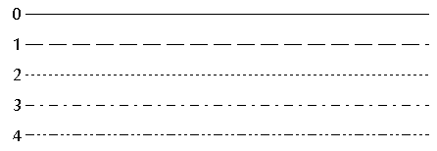
An example of its use is:

Cols_1 = 2, Limits
Style = 1, 0

This would make the data have a patterned line, and the limit a solid line.

StopFreq = <Value in MHz>
This command allows the stop frequency to be specified for the data, no matter what has been tested, ie: StopFreq=350, would force all the data to stop at 350MHz, even if data has been measured to 1GHz. StopFreq over-rules an Overall_StopFreq command.

Graph_Generated_Title = <True | False>
This command allows the graph titles to be generated by the main report software instead by the graphing package. The default setting is TRUE (meaning the graph package will generate the title). This is only really needed if using Chinese characters, as the graphing package can miss-display these.

[TABLE] Section

Example [TABLE] Section

[TABLE]
Title = Attenuation Near (dB)
Slot = 1
Data = Attenuation Near
Cols = 2,3,4,5
Pair = 1,2,3,4
Freqs = 1,4,8,10,16,20,25,31.25,62.5,100,155,200,250,300,350
Headers = Freq, Pair 1, Pair 2, Pair 3, Pair 4

Tables have the following configurable parameters:

Title = <Text>
This is the main title that is displayed in the bar along the top of the table.

Slot = <Number>
The slot command allows the position of the table to be specified as an x and y size of 1 slot, and will position it in the corresponding slot number. Slots are numbered from 1, starting with the top left hand corner.

SizeX = <Number>
The default for this command is 1, meaning that the graph will fill one X slot. Higher numbers can be specified if a graph needs to span several slots.

Data = <Test name> [ | ] [Test Name]
The name of the test to draw data from (exactly as written in the results file). Each table can retrieve the data from only one set of test results. An example of its use is: Data = LCL Near. You can also optionally add an | character followed by another test name, this will allow another test name to be entered, eg: Data=Impedance (O/S) Near | Impedance (Term) Near. This would mean if Impedance O/S was tested then print that, otherwise look for Impedance Term results.

You can also use wildcards in the test name, eg: Data=Impedance (Term)* When these are used in conjunction with the ApplyAllResults command, you could use it to apply statistics on both the near and far end data, so in the example shown, Impedance data from the near and far ends would be combined.

Cols = <Column Number> [,]
The columns to tabulate from the test. With the present data file layout 4-pair cable resides in columns 2,3,4&5. Column 6 & 7 contain the lower & upper limit values. For NEXT, the data columns are 2,3,4,5,6&7. Upper & Lower limits are columns 8&9.

Column numbers can also be defined using the format n..n, for example if columns 2 to 26 were needed, this could be defined as 2..26, rather than typing out all the numbers between 2 and 26.

In addition to normal column numbers, the following variables can be used:
`
Limits Uses the correct limits depending on the test type.
LowerLimit Uses the lower test limit
UpperLimit Uses the upper test limit
LowerControl Uses the lower control limit
UpperControl Uses the upper control limit
Min Takes the minimum value from all pairs
Max Takes the maximum value from all pairs
Max-Min Takes the maximum minus the minimum value.
Mean Takes the average value from all pairs
MaxABSproduct The largest value multiplied by the second largest of all pairs (absolute values).
DL<ColNum> Takes the difference between the column and the lower
limit. (eg: DL2)
DU<ColNum> Takes the difference between the column and the upper
limit. (eg: DU2)

Freqs = <Frequency Value | Variable> [,]
The spot frequencies to tabulate at. The data points displayed are at spot frequencies for a number of data columns. Displayed data are linearly interpolated between nearest recorded results data. Interpolation is performed on the basis of frequency between the two nearest results lines.

In addition to specifying a spot frequency, there are a number of variables that can be used to return statistical data on the whole column, these are:

Min
Max
Mean
StdDev
Max-Mean
Mean-Max
Max-Min
UpperMargin
LowerMargin
UpperLowerMargin
MarginValue
MarginFreq
LowerMarginPercent
UpperMarginPercent
AverageMargin
EMP

The command DEFAULT can also be used, and the information specified in DefaultTableFreqs= will be used.

Headers = <Text> [,]
Each header string value, is printed at the top of each column of data. An example of a header command is: Headers = Freq, Blue, Orange, Green, Brown, Limit

ApplyAllResults = <True | False>
When this option is set to True, any statistics being performed on the data (for example the Average), the data will be calculated from every occurance of a test. For example, if Attenuation had been run 3-times, the average shown would be calculated from all 3 sets of results.

CombineAllResults = <True|False>
When this option is set to True, every occurrence of a test will be combined into the same result set. This is particularly useful if different frequency bands have been tested. The only restriction is that each different set of data must have the same number of points.

ABSData = <True | False>
The default value for this is False. When set to True, the table will use the Absolute data for the results and limits. E.g. if the result was -48 dB, the value plotted in the table would be 48 dB.

ReverseData = <True | False>
The default value for this is False. When set to True, the table will reverse the data plotted on the table. E.g. if the results were -22 and 58, the values plotted on the table would be 22 and -58.

HideFirstCol = <True | False>
When set to True, the first column (normally contains the frequency info) will not be displayed. The default is False.

FontSize = <Number>
The default for this uses whatever the default font size is for your system. This option is useful if you need to get more data into a confined space, as reducing the font size will also reduce the overall size of the table. Typically around 4.5 is the smallest font size that will still allow readable data.

Order_n = <Value>
For a given dataset n, this command indicates which occurrence of a test result to use in the plot. The default is 1 which means take the most recent occurrence (i.e. the last one in the file). If 2 was specified, then it would mean take the 2nd from last occurrence in the file. This is an advanced command, and will not be required for general use.

Format = <Text>
Overwrites the number format specified for the whole report file just for this table. For example, for the number 12.343434:
“0.00” 12.34
“0.0e00” 1.2e01

Example Report Definition File

This Example below defines 2 reports. The first consists of four Impedance graphs; the second is an Attenuation table.

[GENERAL]
Logo= \Agilent.gif
LogoHeight=15

[HEADER]
header_1=[Param1]
header_2=Specification
header_3=[Param3]
header_4=Test Started
header_5=Pre-Test Comments
header_6=Name
header_7=[Param2]
header_8=Description
header_9=Length
header_10=Temperature

[REPORT]
Title=Impedance Near
X=2
Y=2

[GRAPH]
Slot=1
Ymin=60
Ymax=140
Yticks=5
Data_1=Impedance (Term) Near|Impedance (O/S) Near
Cols_1=2,Limits
FollowingGraphs = 3

[REPORT]
Title=Attenuation Near Tabular
X=1
Y=1

[TABLE]
Title=Attenuation Near (dB)
Slot=1
Data=Attenuation Near
Cols=2,3,4,5
Freqs=1,4,8,10,16,20,25,31.25,62.5,100,155,200,250,300,350,400,450,500,550,600,650,700,750,800,850,900,1000
Headers=Freq,Pair 1,Pair 2,Pair 3,Pair 4

Example Printout of Report 1
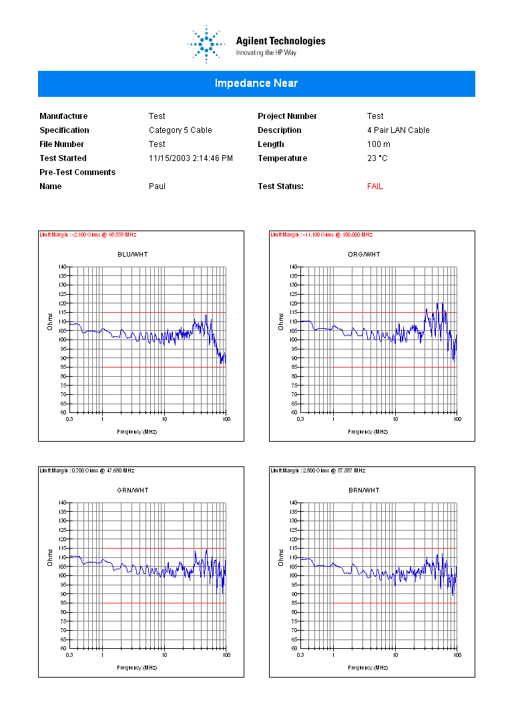

Example Printout of Report 2
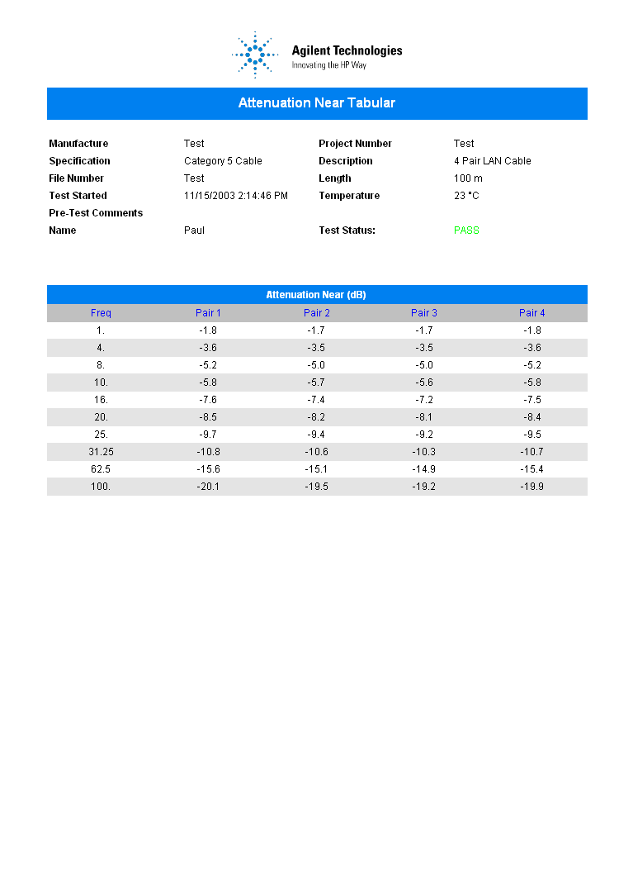

DATABASING

Configuring System Properties

The cable test system has the ability to archive results into a database for trend analysis or archiving purposes. The database is executed from a separate executable file which can be setup in the main test system as follows:

From the main menu, select System Setup, then System Properties.

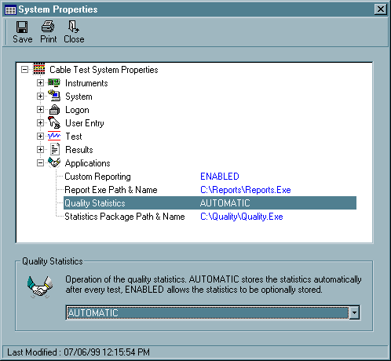

The Applications option contains the items for setting-up the databasing. The Quality Statistics option should be set to AUTOMATIC, and the Statistics Package Path & Name should be set to the location of the databasing file. The default location provided is where the CD installs the program. If you have moved this file, or are running it over a network, the new location can be specified.

For details about setting-up the fields and tables within the database, please refer to the Configuring Database section of the manual.

Database Operation

If the database software is loaded automatically from the main cable test software, it will add the data into the database automatically in the background. If however the actual program file is loaded, the following main screen will be displayed.

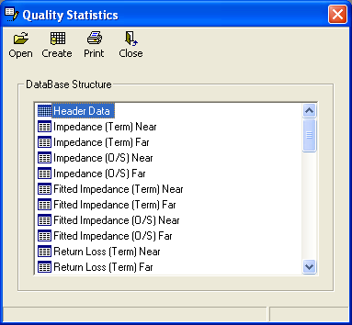

The first time the database software is run, the user should select Create from the menu bar. This will create the empty database structure according to the ini file settings. This procedure only needs to be run when the ini file is first created.

If the ini file is changed, and a database already exists, simply press Create again, and the existing database structure will be updated, to add or modify any existing fields.

To add results to the database, select Open, and from the file selection screen one or more result files can be selected. To select more than one file, hold down the CTRL button while selecting the files. Alternatively, a directory can be selected and every single file contained within that directory and all sub-directories will be selected. To select the directory, press the CTRL button while clicking the Open icon. When CTRL is pressed, the following text will be displayed in the status bar to indicate a directory can be selected:

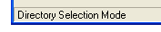

From the main screen, a list of all the tables is shown in the Database Structure box. Clicking on a table name will open a drop-down menu that allows the table structure or the actual table data to be displayed.

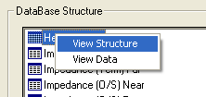

An Example field structure screen is shown below.

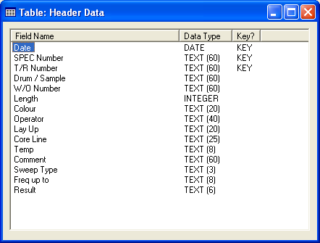

Configuring Database

The following two files allow the database to be generated from the result files. They are installed automatically off the Cable Test CD:

C:\Quality\Quality.exe
C:\Quality\Quality.ini

These files can be moved to another location if required, however both files must be stored together in the same directory.

The Quality.ini file contains all the information about the fields and tables required in the database file. This file can be edited by double-clicking on its icon from within Windows Explorer. An example Quality.ini file is shown below (with text explaining what each section does):

The general section lists the filename of the database file, and the number of tables to be used. If the file specified already exists, it must be of the same format (ie: same number of tables and fields) otherwise an error will occur, the software will not change the format of an existing database.

[GENERAL]
Datafile=C:\Quality\Quality.mdb

It is important that each table has a unique key to identify the data. In this example the test date and time is being used as the key.

[KEY]

[FIELD]
Key = True
Title = Test Date/Time
Data = {Test Started}
dbType = DB_DATE

The setup of the table needs to be setup before any fields can be referenced. The keyword [Table] is used with the first entry name, as it is to be called in the database.

[TABLE]
Name = Header Data
Key = True

Each field entry in the database is referenced using the format [FIELD] as shown below. The entry title is the actual field name that will be written to the database. The entry data is used for the keyword to search for in the result file, this must be contained within {} brackets. The dbType and dbSize entries allow the format of the field to be specified, in this case the data is textual, of up to 60 characters in length.

[FIELD]
Title=Cable Type
data={Cable Type}
dbType=DB_TEXT
dbSize=60

[FIELD]
Title=Cable Type Description
data={Description}
dbType = DB_TEXT
dbSize=60

[TABLE]
Name = Attenuation Data
Key = True

This entry will create a whole set of values at specific frequencies. The variables {FREQ} and {PAIR} are referenced by the frequency and pair numbers. There are 15 frequency entries specified and 4 pairs. This will create a total of 60 (4 pairs x 15 frequencies) new field entries in the database.

[FIELD]
Title= Attenuation at {FREQ} Pair {PAIR}
data= Attenuation Near
cols= 2,3,4,5
Freqs=1,4,8,10,16,20,25,31.25,62.5,100,155,200,250,300,350
headers=

[TABLE]
Name=Impedance Statistics
Key = True

For this example, statistics are being used instead of frequency values. A total of 20 (4 Pairs x 5 statistics) separate fields will be created.

[FIELD]
Title=Impedance {FREQ} Pair {PAIR} Near End
data=Impedance (Term) Near
cols= 2,3,4,5
Freqs= min,mean,max,stddev,max-min
headers=

[TABLE]
Name=Xtalk Statistics
Key = True

In this next example, statistics and frequency points are mixed on the same line.

[FIELD]
Title=NEXT Near {FREQ} Pair {PAIR}
data=NEXT (Pair-Pair) Near
cols=2,3,4,5,6,7
Freqs=max_1_100,max_100_300,max_300_600,1,300
headers=1-2,1-3,1-4,2-3,2-4,3-4

For a complete list of keywords for each section please refer to the following sections of the manual.

If the statistics program is run from within the cable test system, the complete operation will be performed in the background, no user intervention is required.

The structure of the database is displayed in the main window. This allows an ini file to be checked for mistakes before actually creating a database file. The open button will allow a cable test result file to be loaded and added to the database. The print button will send a list of all the database fields and their structures to the printer.

[GENERAL] Section

The [GENERAL] section has the following configurable parameters:

DataFile = <Text>
For an Access database, this entry would contain the directory path and filename of the database file to create, e.g. DataFile = c:\Stats.mdb. For an SQL database, you would use the name of the database, e.g. DataFile = Quality Database. Variables can also be specified for the filename. The variables ‘[DDMM]’ or ‘[YYMM]’ can be used to create a datafile made up of the date and month or year and month numbers. This is of most use when used in conjunction with the AutoCreate command (described below).

DataFile_Fallback = <Text>
This allows a fallback database to be specified in the event that the database specified in the previous command is not available. A typical use of this command could be for a networked database, and if the network is down, a local file could be written to instead. Eg: Datafile = X:\database.mdb DataFile_Fallback = C:\database.mdb

Provider = <Text>
The default for this entry is for an Access .mdb database provider: Microsoft.Jet.OLEDB.4.0 An alternative provider is the SQL server provider: SQLOLEDB.1 If you are using Access, this entry does not need to be specified, it will automatically use the current latest version.

Server = <Text>
This entry is not required for Access databases. For SQL or other similar providers, you would enter the server name where the database is located.

ConnectionInfo = <Text>
This contains any extra connection information required by the database. An example of a possible connection string may be: Jet OLEDB:Engine Type=4; On an Access database, this forces an Access 97 file to be written, instead of the latest format.

AutoCreate = <True|False>
When set to True, the database will be automatically created everytime a new record is added if it doesn’t exist.

DecimalPoint = <CommaReplace | Remove>
This determines how decimal points are handled in fieldnames. A decimal point is considered to be an invalid character by most databases, so can not be used. If the command CommaReplace (the default) is used, all decimal points will be replaced by commas. If Remove is selected, all decimal points will be removed (and any leading zeros).

[KEY] Section

The [KEY] section is optional, and allows one or more [FIELD] sections to be defined as keys. To use it, just define any number of [FIELD] entries as described below but include the command Key=True in each one, and use the IncludeKey=True command in the [TABLE] section requiring the keys.

[TABLE] Section

The [TABLE] section has the following configurable parameters:

Name = <Text>
Contains the name of the table to be stored in the database.

IncludeKey = <TRUE | FALSE>
The default is False. When set to True, any Key fields defined in the previous section will be included in the current table. This means duplicate key definitions do not need to be continually redefined for each table.

[FIELD] Section

The [FIELD] section has the following configurable parameters:

Title = <Text>
Specifies, the title to be used for the current field name. This can be a textual name or can also use variable names mixed with text, for example ‘Attenuation at {FREQ} MHz Pair {PAIR}’ would take the Frequency and Pair entries and use it to derive the field title. Valid variables are: {FREQ}, {PAIR}.

Data = <Text>
The data entry can be used for either a single field, for example: ‘{Cable Length(m)}’, this would search the result file for the keyword Cable Length(m) and extract the single value for it. If a single field entry is being used it must be enclosed in {} brackets. This entry could also have a test name specified to allow multiple fields to be specified, for example to enter spot frequencies. An example could be ‘Attenuation Near’ would use the Attenuation test results.

Cols = <Column Number> [,]
This entry is only required if test results are being used, i.e. for extracting test frequencies, the column numbers for the data is specified here. For example 2,3,4,5 would mean to use those columns from the result file. (2,3,4,5 typically contains the results for pairs 1,2,3 & 4). The following keywords can also be used:

UpperLimit – The upper specification limit.
LowerLimit – The lower specification limit.
Worst – The worst case of all the pairs.

Freqs = <Freq Number> [,]
This entry is only required if test results are going to be used. It specifies the frequency or statistic to use on the data. Valid entries are any frequency number, ie: 0.772, 100 etc. or a variable name can be used to specify that a statistic is required. Available statistics are:

min – The minimum value
mean – The average value
max – The maximum value
stddev – The standard deviation
max-min – The maximum value minus the minimum value
PassFail – Single character indicating either F or P for that pair.
WorstUpperValue – The worst result, compared with just the upper limits.
WorstUpperMargin – The margin at the worst point.
WorstUpperFreq – The frequency at which the worst result compared with the upper limits is located.
WorstUpperSpec – The spec value at which the worst result compared with the upper limits is located.
WorstUpperPair – The pair number of the pair with the worst margin compared with the upper limit.
WorstLowerValue – The worst result compared with the lower limits.
WorstLowerMargin – The lower margin at the worst point
WorstLowerFreq – The frequency at which the worst result compared with the lower limits is located.
WorstLowerSpec – The spec value at which the worst result compared with the upper limits is located.
WorstLowerPair – The pair number of the pair with the worst margin compared with the lower limit.
WorstLower%Value - The worst result compared with the lower limits expressed as a percentage.
WorstLower%Freq - The frequency at which the worst result compared with the lower limits expressed as a percentage is located.
WorstLower%Spec - The spec value at which the worst result compared with the lower limits expressed as a percentage is located.
WorstUpperLowerValue – The worst result, compared with the upper and lower limits.
WorstUpperLowerMargin – The margin at the worst point compared with both the upper and lower limits.
WorstUpperLowerFreq – The frequency at which the worst result compared with the upper and lower limits is located.
WorstUpperLowerSpec – The spec value at which the worst result compared with the upper and lower limits is located.
WorstUpperLowerPair – The pair number of the pair with the worst margin compared with the upper and lower limits.

By default these statistics are applied to the entire frequency range. To limit them to a particular range, the following format can be used command_x_y. Where x is the lower frequency range, and y is the upper frequency range, eg: WorstLowerMargin_50_80 would get the worst lower margin value between 50MHz and 80MHz.

Headers = <Text> [,]
This option is also used for the multiple test results. It is referenced by the variable {Pair} defined in the field title. Typical values could be, ‘Blue, Orange, Green, Brown’ to allow the cable colour names to be used in the title, or ‘1-2, 1-3, 1-4, 2-3, 2-4, 3-4’ could be used to allow crosstalk combinations to be specified.

dbType = <DOUBLE | SINGLE | TEXT | INTEGER | LONG | DATE>
The dbType entry specified the type of the current entry. Allowable values for this are:

DOUBLE Number from -1.7E308 to 1.7E308 (ie: measurement data).
SINGLE Number from -1.18E-38 to 3.34E+38.
TEXT Textual field.
INTEGER Number from -32,768 to 32,767.
LONG Number from -2,147,483,648 to 2,147,483,647.
DATE Date from January 1, 100 to December 31, 9999.

When measurement data is being used, the software will default to using DOUBLE, so it is not necessary to specify the type in this instance.

dbSize = <Integer 1..255>
The dbSize specifies the field length of a text dbType. This can be an integer value of between 1 and 255.

Key = <True | False>
The default for this option is False. When set to True, the field is defined as a Key. This means that data will only be written to the field if other non-key data is found.

Processing = <Text>
This allows the data to be added to the database to be manipulated. A range of string manipulation functions can be performed. The variable F is used to indicate the field data.

If for example, the following command was used: Processing = left(f,2) If the original data contained the value ‘ABCDEFG’, the data added to the database would be ‘AB’

The following commands can be used:

InStr (Start, String1, String2) - Returns the postion of the first occurrence of one string within another.
InStrRev (String1, String2, Start) - Returns the position of an occurrence of one string within another, from the end of string.
Left (String, Length) - Returns a String containing a specified number of characters from the left side of a string.
Right (String, Length) - Returns a String containing a specified number of characters from the right side of a string.
Len (String) - Returns the number of characters in a string.
Mid (String, Start, Length) - Returns a String containing a specified number of characters from a string.
Format (String1, String2) – Formats the data using the standard Visual Basic format types.

SYSTEM SUPPORT

In the event of a genuine problem, please contact the relevant supplier from the list below.

Agilent Instrumentation Support

In the event of a fault occurring with the Network Analyzer, LCR Meter or PC GPIB card, then please contact:

AGILENT TEST AND MEASUREMENT

UK Tel: 07004 666 666
US Tel: (800) 402 0801
Canada Tel: (888) 447 7378
Switzerland Tel: 1 735 9300
China Tel: 010 626 13819
Korea Tel: 2 2004 5800
Taiwan Tel: 0800 478 66

When calling, they will need a description of the problem, and the serial numbers of the equipment. They will arrange for repairs to be carried out in line with your warranty agreement. The above number should also be used, to arrange for the periodic calibration of the instruments.

Software Support

Should a fault or issue arise with the software, please check the ‘Diagnostics’ and ‘Trouble Shooting’ sections in this manual. If there is a genuine support issue or to report a bug, please contact:

Software Support

E-Mail: CSSL@gmx.net
Fax: +44 (0) 870 4321 554

For the fastest response to any problems, please address all issues through e-mail. This process allows the developers to document any changes needed and provide a rapid solution.

Fixture Support

In the event of a Cable Test fixture problem, please contact:

Hardware Support

E-Mail: sales@iesl.co.uk
Tel: +44 (0) 23 8090 5020
Fax: +44 (0) 23 8070 4073

